Articles

On Conflict, Generic and the Informal: the Greek Case
Platon Issaias ⋅ January 27, 2016 ⋅ PDF
This is the second of the two articles by Platon Issaias on the critique of urban informality through the example of the urbanisation of Athens. The first article can be read here.
IThis article was first published in the second issue of Very Vary Veri, the student journal of Harvard GSD.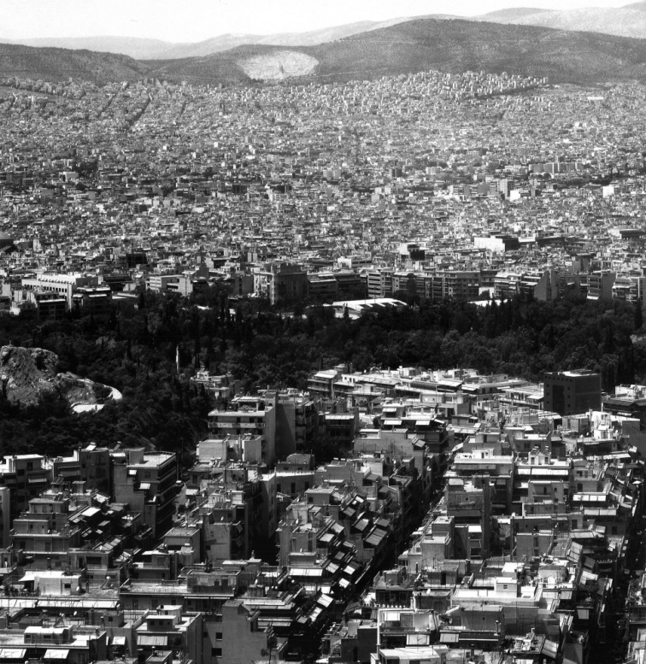
Vincenzo Castella, Athens 2000. Source: Vincenzo Castella, Sitti 98-08, ed. A. Madesani (Milano: Baldini Castoldi Dalai Editore, 2009)
Building on the thesis Beyond the Informal City: Athens and the possibility of an Urban Common (2014), this short essay introduces a few elements of the distinctive urbanization that characterizes the contemporary Greek city. The aim of this essay is to classify the typically Greek method of urban planning and spatial design as an indispensable branch of a complex political project. My objective here is to demonstrate the way in which social transformation in Greece has been primarily achieved by—and occurred within—the development of specific architectural and urban types as well as planning protocols. This body of tools and design procedures was used to administer social relationships; it put space at the epicenter of political and social antagonism. As a sophisticated institutional framework that employs a process of subjectification, it framed forms of life, corresponding practices, and conditions of occupation. Simultaneously, this method of producing architecture composed a characteristic economic, material, and spatial entity. The strategy of my research is precisely to unveil how this form of domesticity constitutes the concrete materialization of a set of relations that governed the Greek city, managing and controlling its territory and population from within the economy of the typical household and the sphere of its social reproduction, the housing unit itself.
In the Greek city, the domestic monad acquired its highest and most complex resolution as a managerial, bio-political device in the form of a particular type of architecture: the “polykatoikia.” This term stands for the small-scale, multi-story apartment building, and ultimately refers to a method for constructing and disposing multiple housing units and apartments within a single plot of land. The resulting architectural object defines the urban horizon of Greece by its singularity, a condition that becomes apparent when one experiences in situ, or even just looks at an image of, Athens or any other Greek town.
As a revealing case study, the Greek city allows us to re-think the distinction between “formal” and “informal” urbanization. These two dialectically opposed categories distinguish two types of planning, which supposedly represent equally opposite managerial processes to formulate contemporary urban environments. Whereas the first echoes the tradition of central decision-making and planning, which implies a strong involvement of the state in the management of space, the second assumes a process whereby the lack of governmental control has been replaced by a type of city development based on seemingly autonomous and impromptu popular practices. However,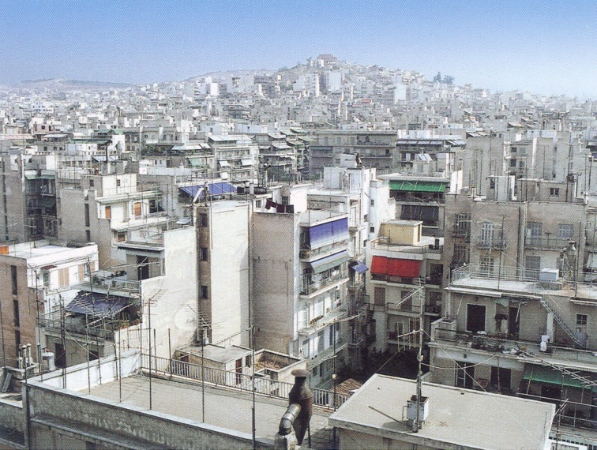
View of central Athens, 2000. Source: Dimitris Philippides’ personal archive in the Greek case, what appears to be a spontaneous and unplanned urban typology is in fact the result of a meticulously detailed regulatory structure that evolved strategically through time. This legislative frame produced not only the characteristic Greek urban space and its emblematic “polykatoikia” building, but also eventually established a common architectural language, a unified and unifying building knowledge and technique that built a sporadic and highly fragmented city.
II.
With all of this in mind, I will deploy here categories of political economy to analyze conditions and phenomena of the urban. My research presents the process of city management through a specific methodological lens, which understands conflict as the generator of spatial and societal transformations in the city, and production as the space where this antagonistic relationship primarily occurs. Conflict and struggle are the two instrumental categories to confront the notion of “crisis” as an ongoing, never ending project of capitalism, not as a mere malfunction of the capitalist economy and its cities. The rhetorics of “crisis” and its multifaceted agents are the elements that stand for the reactionary opposition to social change; it is precisely what constitutes the counter-program to the exact possibility of social struggle. In this particular moment, the status of the neoliberal paradigm and the intense political conflicts around the world, together with the acute problems of contemporary cities, make this encounter one of historic urgency, especially when it comes to tackling the impossible rationale of free-market urbanism. However,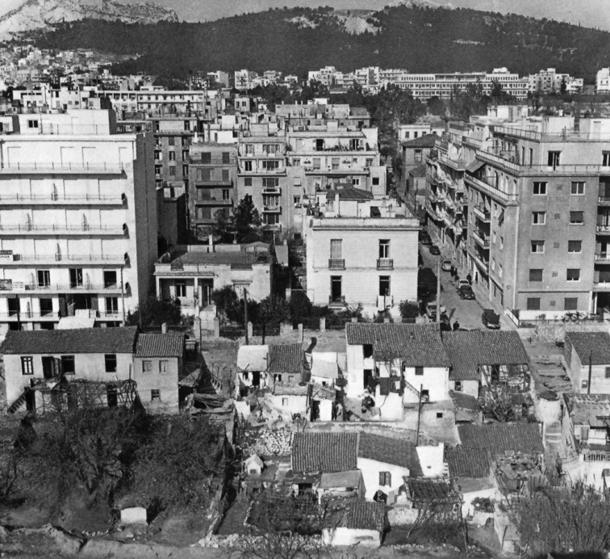An Inner City Squatter’s Settlement in Athens, 1966. Source: Dimitris Philippides, “Town Planning in Greece”, in 20th Century Architecture in Greece (New York: Prestel Publishers, 1999). Courtesy of Dimitris Philippidis Archive. one should aim to go beyond a cause-and-effect relationship between space, architecture, the economy or the political itself, and instead speculate on the strategic link between production in general—and production of space in particular—with the city and its machines of administration. The understanding of the politics of labor in relation to space production and occupation, as well as the transformation of the social and economic organization of labour itself, can give rise to a methodological operation that challenges the notion of the “informal” in the contemporary discourse on the urban and its properties. In order to push back against the distinction between “formal” and “informal” urbanization, we should understand both as projects that attest specific power relations and forms of governance, through spatial and physical design, of a territory and its population. The “presence” or “absence” of formal properties in the design of cities is evidence of violence in regards to the division of labour, forms and accumulation of property and wealth, methods of production, and the very function of power as well as its administrative infrastructure. More to the point, how can we relate the management of space at large in the city with the administration of life within the space of its typical domestic unit? What is the relation between the domestic, the work of production, and conflict in the city?
III.
In his essay “The rationality of Capitalism,” Cornelius Castoriadis describes capitalism as a regime that “precisely, and above all, […] was born and developed in a society in which conflict, […] was present from the outset,”[1]1. Cornelius Castoriadis, ‘The rationality of Capitalism’, in Figures of the Thinkable, trans. Helen Arnold (Stanford: Stanford University Press 2007), p. 55.
2. Ibid., 54. stressing that its core social imaginary signification is “the thrust towards the unlimited extension of rational mastery.”[2] Castoriadis also remarks that “rationalization,” as the true trend in the historical creation of capitalism, is the concept that allows it to survive as a true “mastery” since it cannot be produced or deduced by anything else. This mastery is primarily internal, and tends to conquer the totality of bios and zoe. “[…] this thrust towards mastery is not oriented towards ‘foreign’ conquest, but is aimed just as much, or more, at society as a whole. It must be achieved not only in production, but in consumption as well, and not only in economy, but also in education, law, politics, and so on.”[3]3. Ibid., 53. Its success is based precisely on its capability to extend rationality beyond profit and economic expansion to an ontological condition.
It is through this the lens that we can understand urbanization as an episteme born along a historic process to define the ingredients of the modern concept of governmentality within capitalist economy. It is essentially in the organization and control of the space where this productive activity could best occur, which expands to the realm of social reproduction, the domestic space itself. The true object of capital, and therefore, the true objective of urbanization, is the management of the potential—life and welfare of producers, which implies a philosophical paradox. The true essence of capitalist rationale and its practice of spatial control is the management of something that does not exist—it is the potential of production and both time and possibility of development. This relation between the urban, economic management and administration of production becomes therefore central. This is the moment city management established its critical bond with economy and the process of subjectification. The critical point therefore is to understand how economy becomes not only the paradigm of the praxis of administration, but also the process through which produces its own subject.
As Maurizio Lazzarato pointed out in the Making of the Indebted Man,[4]4. Maurizio Lazzarato, The Making of the Indebted Man, trans by Joshua David Jordan, (Los Angeles, CA: Semiotext(e), 2012).
5. David Graeber, Debt: The First 5,000 Years (New York, NY: Melville Publishing House, 2011). this issue of future development and the management of its uncertainties become even more critical today, especially within the mechanisms of exploitation and domination produced in contemporary financial capitalism in the debtor-creditor relation. As Lazzarato argues, this dialectic scheme lies in the very core of the neoliberal project and, far from being a pathogenesis or a ‘malfunction’ of monetary capitalism, constitutes the very process that destroys the past distinctions of the welfare state between workers and the unemployed, consumers and producers, working and non-working populations, between retirees and welfare recipients. As Lazzarato further explains, Capital initiates an ontological guilt and dept becomes a political construction, which cannot be reduced to an economic mechanism, but constitutes a device of governance and control. By a technique where the honor of a private or public debt and the minimization of uncertainty are placed in the centre of contemporary economic policies and political debates, the exchange of time and money in the future pushes for the reconfiguration of the entire material and existential horizon of the debtor. In his book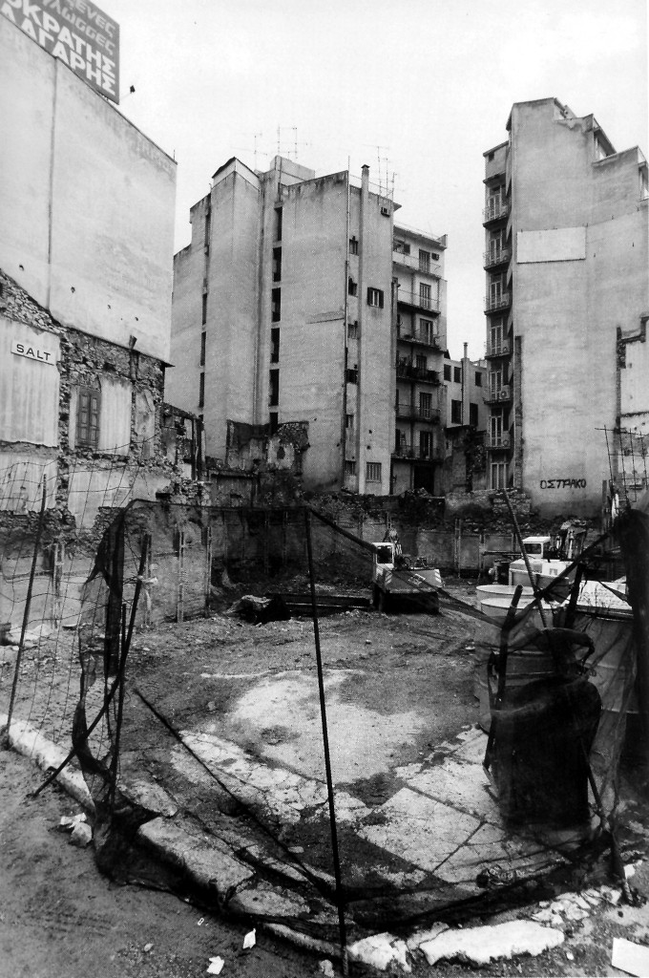
Manolis Baboussis, Construction Site. Source: Athens: 1985 -1996, Μ. Baboussis personal archive. Debt: The First 5,000 Years, the anthropologist David Graeber significantly expanded this position, arguing for a much longer historic instrumentality of debt in relation to the organization of human societies.[5] From the virtual transactions of early agrarian societies to primitive accumulation based on gold and silver, i.e. real money, to contemporary financial capitalism, the process of constructing “the debtor” is crucially linked with the construction of the oppressed. The “slaves of debt” have nothing more to valorize but their future, i.e. their own existence as producers who owe each time anew their own productive capability. The sovereign debt “crisis” of the Greek State coincides with a colossal restructuring of the model of its economic development, a “crisis” of the economy of the city and a violent transformation of the productive basis in Greece. Elements and traces of this violence preceded the International Monetary Fund/European Union agreements, and could be detected even in the late 1990s. During the five decades following the Second World War, the organization of labour in the construction industry and the evolution and diffusion of the polykatoikia model created a condition where this productive activity became central to the Greek economy. Investment in land and property became a popular practice for the working and the middle class. This process was severely challenged by neoliberal economic reforms of the real estate market at the time when Greece was entering the Eurozone in 2001, a project that continued after the 2004 Athens Olympic Games. Today, due to the systemic modification of land and taxation policies, what originally seemed to be a form of investment and wealth has become a device of extreme exploitation through the institution of debt. The collapse of this model must therefore be discussed in light of Lazzarato’s and Graeber’s concepts. In a process of further “rationalization” of economic transactions related to real estate, urban space in Greece is “de-valorized” such that large corporations and banks may acquire and accumulate it from the hands of the indebted, the class paradoxically made up of the original producers and owners of this very space, now the device of their own subjectification.
The fact that modern capitalist development constructs a regime, which, as a totality, is based on the dissemination of an agglomerate of different apparatuses, explains it as a project that implies the “extreme proliferation in processes of subjectification.”[6]6. Giorgio Agamben, What is an Apparatus? And Other Essays, trans. by David Kishik and Stefan Pedatella (Stanford, CA: Stanford University Press, 2009), 15. This poses a structural political problem regarding the constant struggle between the individual and the devices of control, since these construct multiple fragmented renditions of the being in different “sub/multi-subjectivities.” This process of destroying the individual being achieves an even more efficient governance of society, disguising the main plane of antagonism that occurs in the space of production between the two elemental subjects: producers and holders of the means of production. The political challenge lies not in the denial or destruction of these apparatuses, but rather in claiming that the very processes of subjectification, the most elemental of which is the one taking place the moment labour power, the potentiality of the worker is captured and exploited in the productive process.
IV.
With regards to spatial administration and territorial management, this alternative could be based on an architectural paradigm that would claim space itself as an apparatus and re-appropriate it as a form of productive activity. This is particular necessary when we take into account the profound transformations of the capitalist city, where production and the extraction of value has shifted from previous paradigms of spatial organization (such as that of the factory or the office), to the city as a whole. This does not mean that these previous spatial archetypes have disappeared, but that the management of every aspect of life has been achieved by the diffusion of exploitation in any form of activity in the city. Today, labour is the core of any form of production, absorbing sets of relationships in the continuum of the urban and expanding the real essence of economy – the nomos of the oikos, or in other words the administration of what belongs to the house – to the city as a whole. There is a profound relationship between the nature of labour and architecture, which occurs in the space of production itself. That is the notion of the generic, which exists and defines both concepts, especially in the contemporary city.[7]7. These methodological observations and analytical framework were first elaborated and formed the basis of the second–year design studio “Labour, City, Architecture” taught at the Berlage Institute in the academic year 2010-11. (tutors: Pier Vittorio Aureli, Maria S. Giudici, Platon Issaias, Elia Zenghelis). For more on the project: Pier Vittorio Aureli, Maria S. Giudici, Platon Issaias, “From Dom-ino to polykatoikia”, Domus 962 (October 2012): 74-87. Pier Vittorio Aureli, Maria S. Giudici, Platon Issaias , “Labour, City, Architecture: Athens as a case study”, Made In Athens, catalogue of the Greek Pavilion on the 13th International Architectural Exhibition- Venice Biennale, ed. Panos Dragonas, Anna Skiada (Athens: YPEKA, 2012), 313-319. Maria S. Giudici, “Education, Consumption, Production: Three Cautionary Tales”, Architektur + Analyse 3 Is There (Anti-)Neoliberal Architecture? Ana Jeinić, Anselm Wagner (eds.), (Berlin: Sovis Verlag, 2013), 88-103.
8. Karl Marx, Economic and Philosophical Manuscripts, in Early Writings, translated by Rodney Livingstone and Gregor Benton (London: Penguin Classics in association with New Left Review, 1975) 279-400.
The term “generic” comes from the Greek word genikos («γενικός»), the one that belongs to a specific “race” or “kind,” genos in Greek («γένος»). The actual activity implied by the term is that of the verb ginomai («γίνομαι»), which describes the process of “coming-into-being,” “of one (a being) producing oneself,” i.e. becoming a subject. The term “generic” therefore refers to a condition or a property of a being that pre-exists the individual, the social subject and thus, as a category, is strongly linked with the category of labour. According to Marx, man as an entity becomes a social individual that consists of both singular determinations and generic faculties. In his “Economical and Philosophical Manuscripts,” Marx merges pre-individual characteristics of human life and the generated life activity into one human essence through which human beings become aware of their own subjectivity.[8] That is production, which has to be understood as the generic activity of the human being par excellence, something that is irreducible to any specific form of labour, a pre-individual capability to produce, and something of which labour power is its most concrete manifestation. The possibility of production includes not only production itself, but also the re-production of the species, i.e. the domestic sphere and all the other schemes and devices that guarantee the welfare of the being.
The importance of production lies on the fact that the mastery of capital appears in the rationality of the generic in the organization of the productive process as a whole. Labour as a generic entity, constitutes a general category that describes a wealth-creating activity without any limiting specification. In “Grundrisse,” Marx described that this abstraction becomes true and obvious only in modern societies, where labour in reality became the means of creating wealth in general, linking all specific activities to one and impartible whole. “The point of departure of modern economics, namely the abstraction of the category of ‘labour,’ ‘labour as such,’ labour pure and simple, becomes true in practice.”[9]9. Ibid., 19. The crucial point is how this activity enters the capitalist process. Labour exists before production, before the stage where it could extract profit, i.e. before entering the category of value.
V.
In his essay “The Strategy of Refusal,” Mario Tronti describes the dialectic relation between labour and capital, and it is from this relationship that the category of conflict arises.[10]10. Mario Tronti, ‘The Strategy of the Refusal’, on ‘Initial Theses11’ in Tronti’s Operai e Capitale (Turin: Einaudi 1966): 234-252. (English translation available online, accessed 07/12/2013: http://libcom.org/library/strategy-refusal-mario-tronti). It is the moment when the conditions of labour confront the form of capital. This is when productive labour is transformed into wages, the moment when “laborers are transformed to workers,” which is to say that the potential residing in labour power is captured by capital. According to Tronti, this is the moment when the whole society confronts the rationale of capital as an apparatus of production, the aim of capitalist society in general. Conflict and struggle exist within the capitalist process as an indispensable part in the form of antagonism within production itself. As Tronti states, “capitalist power seeks to use the workers’ antagonistic will-to-struggle as a motor of its own development,” which means that it is the workers’ organization and class that fuels development and not the opposite.[11]11. Ibid., 236. The suggestion here is to establish a dialectic relation between class struggle and capitalist initiative, or in other words, to think which one precedes the other. Within this scheme, conflict and struggle are understood to exist within the structure of capital production and re-production as an antithesis from the beginning of the capitalist process. Labour defines the social condition of capital itself. The true cost that capital has to pay is the potentiality of struggle, since conflict always exists from the outset of its own organization. In regards to space, the exchange of wellbeing and material wealth is paid for by acceptance of the violence of administration in an array of social contracts and rationales.
These methodological tools and analytical categories allow us to discuss contemporary forms of urbanization as direct evidence of places of conflicts and struggles that occurred within the space of production. Conflict, as an indispensable part of capitalist organization, stands as the “motor,” the device that produces capitalist transformation and the evolution of specific forms of production in general as well as types/protocols of space in particular. Our aim here should be to unveil how planning of any kind, i.e. administration of the city through managerial devices, directs and apportions conflict over the territory of the city from within an economic regime that places the production of architecture and the construction of domestic life at the centre of its machine of dominance and control. This is what “informal” urbanism precisely exacerbates, being a form of city design that had produced a type of domestic architecture unanimously linked with economic development. It constitutes a system within which space and land ownership have been understood and instrumentalized as the most primordial and essential productive assets. A system promotes the economy of construction, the building industry, as the epicenter of production and the main tool in the hands of administration to govern space and the city as a whole.
VI.
All of the above notions allow us to see the form of Greek urbanization as direct evidence of the conflicts and struggles that occurred within the space of production, throughout the recent history of the country. As it has been described previously, conflict, as an indispensable part of capitalist organization, stands as the “motor,” the device that produces capitalist transformation and the evolution of specific forms of production in general, and types/protocols of space in particular. Greek cities as case studies, and especially the history of Athens, unveil how planning of any kind, i.e. administration of the city through managerial devices, directed and appropriated conflict over the territory of the city from within an economic regime that placed the production of architecture and the construction of domestic life at the centre of its machine of dominance.
In less than two centuries, from 1834 when it was chosen to become the capital of the newly independent Greek Kingdom, Athens grew from a small Ottoman town of 6.000 inhabitants to a dense metropolitan area of 4 million which covered the Attica Basin. This acute enlargement resulted from consecutive waves of human displacement, in respective periods of the city’s recent history. From the first wave of public servants, military personnel, court officials and entrepreneurs during the early years of the capital, to the massive growth of the working class in the city of the early 20th century, and from the 250,000 refugees from Asia Minor of 1922, to the colossal internal immigration inflow of the 1950s and 60s, Athens had to be significantly densified and expanded in order to accommodate such fundamental transformations. These instances should be read as moments of interruption, of radical change in the city’s social consistency, within which the notion of “crisis,” the pressure of social conflict and the ever-increasing housing needs instructed immediate political responses.
Ever since this city’s initial stages of development, the discourse on what type of city planning to employ, and what type of architecture, had been closely linked with a particular mode of economic development, within which space and land ownership had been understood and instrumentalized as the most primordial and essential productive assets. It is the economy of construction, the building industry – i oikonomia tis oikodomis[12]12. Oikodomi («οικοδομή» in Greek) is the term used to describe a building under construction, but also the array of processes related with the construction of buildings of any kind. It’s a composite word from oikos (the house) and domi, which signifies the structure of a thing, the way an entity is composed by different elements. Domi is also the origin of the latin word Domus, eventually meaning the dwelling. – as this appeared and developed in Athens first, and elsewhere in Greece respectively, which have become the epicenter of production in general and the subject of spatial administration of the city as a whole. This has been achieved by the mechanisms of its own development and reproduction, fueling capital accumulation and concentrating most of the monetary activities of the different social classes. Whether speculative, opportunistic, conscious or spontaneous, desperate acts or deliberate collective initiatives, urban or peripheral, these spatial and building practices defined a method of city planning where the state limited itself to providing just the platform, which, in the form domestic archetypes, defined an environment, within which these popular praxes could flourish. This function of the Greek state in regards to city planning could be read as the very definition of the role of the state and its various institutions in the market economy. Contrary to the widespread rhetoric about free-market economics, the persistent presence of the state affirms the necessity of its very existence within this economic regime, which eagerly needs the latter to define the modus operandi that allows for its promotion and dominance. The state and its institutions not only guarantee the sovereignty that allows a territory to be economically exploited, but primarily provide the juridical and regulatory framework that institutionalizes capitalism’s very essential functions: private property, method of production and social division of labour. The neoliberal mantras of deregulation and “laissez-faire economics” disguise this almost existential precondition of capitalist development, which requires the more-than-dominant presence of state administration throughout the productive process. The qualitative difference of neoliberal governmentality is the replacement, the apparent absence of central planning with a network of managerial processes that private actors execute.
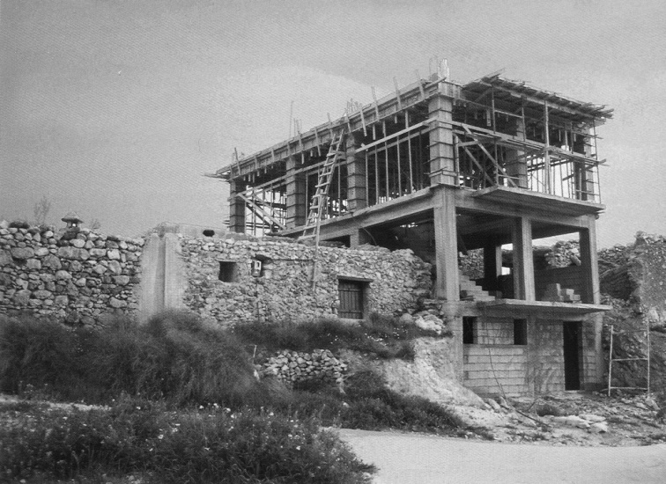
GreekSelf-built domestic unit in the periphery of Athens. Source: Dimitris Philippides, Modern Architecture in Greece (Athens: Melissa Publishers, 2001), 73.
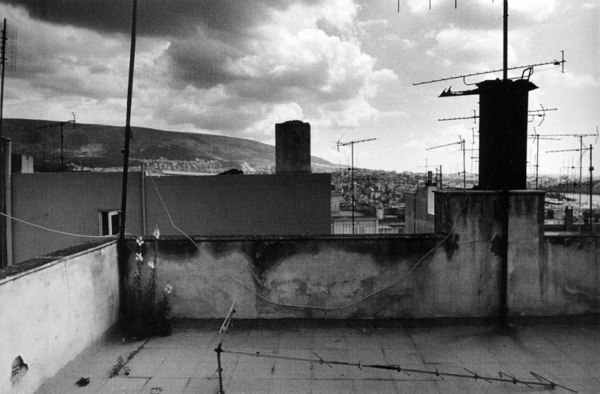Manolis Baboussis, Terrace. Source: Athens: 1985 -1996, Μ. Baboussis personal archive. cities should be read as a clear manifestation of spatial management and capitalist planning. The historical circumstances and the particular geopolitical conditions of Greece were conducive to this mode of city planning, which has been often labeled as the aftermath of “informal” development. This approach neglects the local socio-economic structures and operations undertaken by public authorities, or misinterprets the political and social context that produced this type of urban management in the first place. The fact that the Greek economy was similarly based on small-scale businesses, sporadic self-employment and fragmented organization of the labour force added further to the classification of this urban landscape as a “self-made,” almost accidental development. In other instances, the architecture of the polykatoikia and the history of this typology were studied almost independently from the modes of production and the forms of labour and property in the Greek city and society. These studies approached the polykatoikia more as a local adaptation of postwar modernism, as an architectural style, or as a positive effect, an emblematic resolution of a metropolitan lifestyle that modernized Greece after the Second World War.
The spatial and architectural characteristics of the polykatoikia were ultimately the media that captured and rendered profitable the productive potentialities residing within these existing forms of labour, transforming the labour power and the potential of producers into wealth, property and surplus capital in Greece. The advancement of this method of urbanization should be understood as the preeminent device of a much broader agenda, which aims for the capitalist integration of Greece, an underdeveloped country of the European South. “Spontaneity” and “informality” are the attributes that disguise the very nature of this strategy, with its final goal being the establishment of a privately owned and controlled urban environment in extremis. This project took its most apparent resolution in the second half of the twentieth century with the polykatoikia but, as my thesis argues, it has its origins in the foundation of the Modern Greek State in the 1830s. Since then, city planning was carried out primarily by the manipulation of singular architectural objects, by a small-scale, mainly private architecture, while large-scale masterplans gradually became obsolete and altogether ineffective. Instead of being addressed, the existing fragmentation of property was further intensified in order to promote specific forms of production, capital accumulation and monetary circulation within a rather small-scale construction sector. The success of this project, especially in the last six decades, was based exactly on its capability to present itself as a self-originated, self-help mode of welfare, within which entering the realm of private property constituted the ultimate social imaginary and form of wealth for different social subjects in Greece.
VII.
If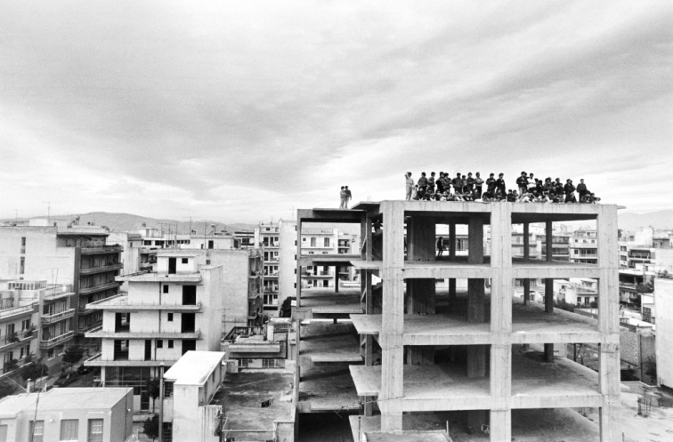Manolis Baboussis, Κallithea, 1987. source: Athens: 1985 -1996, Μ. Baboussis personal archive. the polykatoikia is the architectural object of post-war reconstruction in Greece, the “antiparochi” was the system that made it possible: the element that executed the latent project of the contemporary Greek city. This mechanism can be accurately described as a “private contract” between individuals. It not only multiplied to the extreme the dominance of private property, but also replaced advanced capitalist methods of financing in the building sector. The land owners had the opportunity not only to acquire a newly-built apartment to upgrade their living, but also to increase their income and their private assets, simply by owning properties or by renting the apartments they didn’t use as their own house. House occupants, average or poor households understood themselves as potential entrepreneurs and land speculators. Dowries, apartments as “gifts” to younger family members, extensive tax evasion was not only tolerated but accepted as an indispensable part of the Greek economy. Apart from the unskilled labour force of the construction workers, related employment, such as architects, civil and mechanical engineers and even lawyers and conveyancers, became the spine of the native middle class. Many of these professions, with their incomes being fueled by the activities within the building industry, had their wages regulated and secured by the state, which legislated accordingly. At the same time, the contractors were able to obtain land without bank loans or other public subsidies. Again, the absence of a direct presence or interference of public authorities within this process depicted the latter as a self-initiated and autonomous economic activity.
The proliferation of this mechanism resulted in the formulation of a unified construction market, where all the actors and agents were simultaneously operating in different building scales and areas of the city. The most important effect of this phenomenon was the emergence of a common architectural technique, a consistent building technology based on local materials, cheap methods and manual labour, with the polykatoikia being the emblematic resolution, the architectural form that incorporated and illustrated these complex socio-economic activities. The generic architecture of the archetype became the shareable knowledge of space and occupation for the producers and the inhabitants of the city. The polykatoikia materialized the “social contract” of the post-war reconstruction, being the machine with which Greek society exchanged the possibility of social change with material wealth, overwhelmingly entering the imaginary of private property. Defined as a “necessity” in the aftermath of the 1944-49 Civil War and executed as a seemingly unplanned, informal strategy, it became the point where the opposing camps of the conflict met, agreeing upon the form, content, and character of economic development and social welfare in Greece.

It is in this history that the various political and economic relations, the struggles and the social desires of the Greek society may be read. Contractual agreements between individuals, property owners and contractors, forms of labour and employment, family structure, gender and class domination, and ultimately, the patterns of estrangement and disenchantment in the urban space are registered in polykatoikia’s continuous slabs and plastered brick walls. The polykatoikia is the system through which the city has been transformed into a continuous, uninterrupted productive landscape. A complex spatial machinery of social engineering, capable to exploit labour power, diffuse production and foster accumulation of capital in every space and territory of the Athenian an the Greek landscape. It is a device of subjectification, of class differentiation and social alienation, presented as self-help, welfare project. It produced a vast Greek middle class, the constituents of which were simultaneously owners, producers and consumers of space, in a paradoxical manner. Nevertheless, it is a class and a society of debtors.

