1^{η} Πρόοδος Δυναμική και Έλεγχος Διεργασιών 4 Ιουνίου 2018
ΘΕΜΑ1 (10μονάδες)
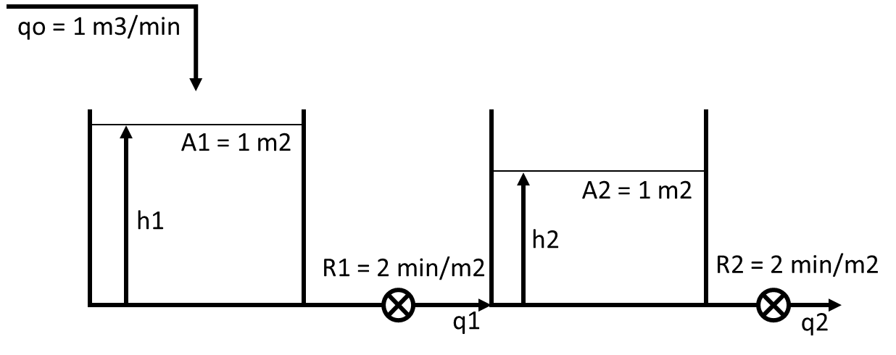
Σε χρόνο 0 η παροχή αυξάνεται βηματικά κατά 1 m3/min. Να υπολογιστεί και να παρασταθεί γραφικά (σε χρόνο 0, 5, 10, 20, 40 και 60 min) η απόκριση της στάθμης στην 1^{η} και τη 2^{η} δεξαμενή.

@SS 1 – (h1s – h2s)/2 = 0 (h1s – h2s) = 2 h1s = 4
(h1s – h2s)/2 – h2s/2 = 0 h2s = 2

Ισοζύγιο μάζας στην 1^{η} δεξαμενή
qo(t) – (h1(t) – h2(t))/R1 = A1*dh1(t)/dt Qo(t) – H1(t)/2 + H2(t)/2 = 1*dH1(t)/dt
2*Qo(t) – H1(t) + H2(t) = 2*dH1(t)/dt 2Qo(s) – H1(s) + H2(s) = 2sH1(s) (1)

Ισοζύγιο μάζας στην 2^{η} δεξαμενή
(h1(t) – h2(t))/R1 – h2(t)/R2 = A2*dh2(t)/dt h1(t)/2 – h2(t)/2 – h2(t)/2 = 1*dh2(t)/dt
h1(t) – 2*h2(t) = 2*dh2(t)/dt H1(t) – 2*H2(t) = 2dH2(t)/dt H1(s) – 2H2(s) = 2sH2(s)
H1(s) = (2s + 2)H2(s) H2(s) = H1(s)/(2s + 2)

(1) 2Qo(s) – H1(s) + H1(s)/(2s + 2) = 2sH1(s) 2Qo/H1 – 1 + 1/(2s + 2) = 2s Qo/H1 = s – 0,5/(2s + 2) + 0,5
Qo/H1 = (2s2 + 2s – 0,5 + s + 1)/(2s + 2) H1/Qo = (2s + 2)/(2s2 + 3s + 0,5)
H1/Qo = 2s/(2s2 + 3s + 0,5) + 2/(2s2 + 3s + 0,5)

(1) 2Qo(s) – (2s + 2)H2(s) + H2(s) = 2s(2s + 2)H2(s) 2Qo/H2 = (2s + 2) – 1 + 2s(2s + 2)
Qo/H2 = s + 1 – 0,5 + 2s2 + 2s = 2s2 + 3s + 0,5 H2/Qo = 1/(2s2 + 3s + 0,5)

Βηματική διαταραχή της παροχής: qo(t) = 2u(t) qo(t) – qos = 2u(t) – 1u(t) Qo(t) = 1u(t) Qo(s) = 1/s

Λύση τριωνύμου Δ = 9-4*2*0,5 = 5 x1 = (-3+5^0,5)/4 = -0,191 x2 = (-3-5^0,5)/4 = -1,309
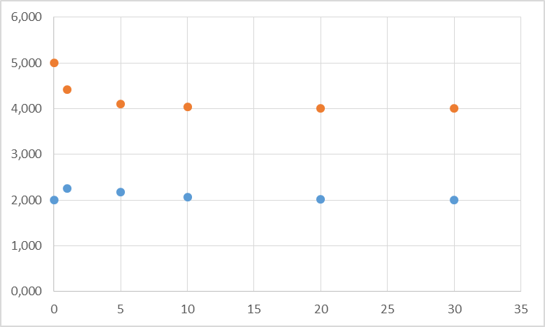
HEAVYSIDE
1/(s + 0,191)(s + 1,309) = A/(s + 0,191) + B/(s + 1,309)
A = 1/(-0,191+1,309) = 0,894
B = 1/(-1,309+0,191) = -0,894

1/2s(s + 0,191)(s + 1,309) = Γ/s + E/(s + 0,191) + Z/(s + 1,309)
Γ = 0,5/(0,191*1,309) = 2,000
E = 0,5/(-0,191)*(1,309-0,191) = -2,927
Z = 0,5/(-1,309)*(-1,309+0,191) = 0,427

H1 = 0,894/(s + 0,191) – 0,894/(s + 1,309) + 4,000/s – 5,853/(s + 0,191) + 0,854/(s + 1,309)
H1(t) = 4+0,894*exp(-0,191*t)-0,894*exp(-1,309*t)-5,853*exp(-0,191*t)+5,853*exp(-1,309*t)

H2 =2,000/s - 2,927/(s + 0,191) + 0,427/(s + 1,309) H2(t) = 2-2,927*exp(-0,191*t)+0,427*exp(-1,309*t)

t | H1 | h1 | H2 | h2 | t | H1 | h1 | H2 | h2
0 | 1,000 | 5,000 | 0,000 | 2,000 | 10 | 0,041 | 4,041 | 0,066 | 2,066
1 | 0,424 | 4,424 | 0,249 | 2,249 | 20 | 0,006 | 4,006 | 0,010 | 2,010
5 | 0,107 | 4,107 | 0,171 | 2,171 | 30 | 0,001 | 4,001 | 0,001 | 2,001

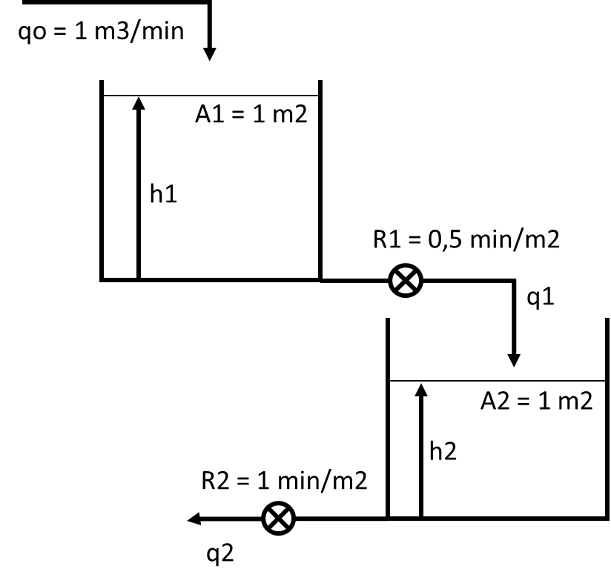
ΘΕΜΑ 2 (10 μονάδες)

Στο σύστημα δεξαμενών η παροχή αυξάνεται βηματικά κατά 1 m3/min. Να υπολογιστεί η στάθμη των δύο δεξαμενών σε χρόνο 0, 1, 2 5 και 10 λεπτά.

Βηματική μεταβολή της qo: qo(t) = 2u(t) qo(t) – qos = 1u(t) Qo(s) = 1/s

Ισοζύγιο μάζας στην 1^{η} δεξαμενή
@SS 1 – h1s/0,5 = 0 h1s = 0,5

qo(t) – h1(t)/R1 = A1*dh1(t)/dt Qo(t) – H1(t)/0,5 = 1*dH1(t)/dt
0,5*Qo(t) – H1(t) = 0,5*dH1(t)/dt 0,5Qo(s) – H1(s) = 0,5sH1(s)
0,5 – Η1/Qo = 0,5sH1/Qo H1/Qo*(0,5s + 1) = 0,5 H1/Qo = 1/(s + 2) (1)
H1 = 1/s(s + 2) (2)

HEAVYSIDE 1/s(s + 2) = A/s + B/(s + 2) A = 0,5 B = -0,5

(2) H1 = 0,5/s – 0,5/(s + 2) H1(t) = 0,5*(1 – exp(-2t))*u(t)

t | 0 | 1 | 2 | 5 | 10
H1 | 0 | 0,432 | 0,491 | 0,500 | 0,500
h1 | 0,500 | 0,932 | 0,991 | 1,000 | 1,000

q1(t) = h1(t)/R1 Q1(t) = H1(t)/0,5 Q1(s) = H1(s)/0,5 H1 = 0,5Q1

(1) 0,5Q1/Qo = 1/(s + 2) Q1/Qo = 2/(s + 2)

Ισοζύγιο μάζας στην 2^{η} δεξαμενή q1(t) – h2(t)/R2 = A1*dh2(t)/dt Q1(t) – H2(t)/1 = 1*dH2(t)/dt
@SS 1 – h2s/1 = 0 h2s = 1 Q1(s) – H2(s) = sH2(s) 1 – Η2/Q1 = sH2/Q1
H2/Q1*(s + 1) = 1 H2/Q1 = 1/(s + 1) (3)

H2/Qo = (H2/Q1)*(Q1/Qo) = (1/(s + 1))*(2/(s + 2)) = 2/(s + 1)(s + 2)

H2 = 1/s(s + 1)(s + 2) (4)

HEAVYSIDE 1/s(s + 1)(s + 2) = A/s + B/(s + 1) + C/(s + 2) A = 0,5 B = -1 C = 1/(-2)((-1) = 0,5

(4) H2 = 0,5/s + 0,5/(s + 2) – 1/(s + 1) H2(t) = 0,5*(1+exp(-2*t)-2*exp(-t))*u(t)

t | 0 | 1 | 2 | 5 | 10
H1 | 0 | 0,200 | 0,374 | 0,493 | 0,500
h1 | 1 | 1,200 | 1,374 | 1,493 | 1,500

ΘΕΜΑ 3 (10 μονάδες)
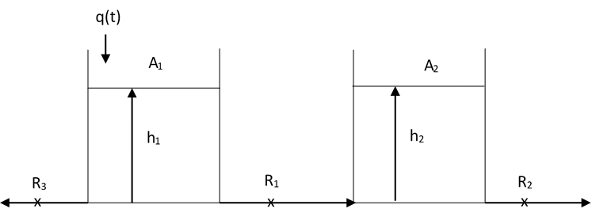
Σε χρόνο 0, προστίθενται στιγμιαία 2 m³. Να υπολογιστεί και να παρασταθεί γραφικά (σε χρόνο 0, 0,5, 1, 2 και 5 ώρες) η απόκριση της στάθμης στην 1^{η} και τη 2^{η} δεξαμενή. Οι αντιστάσεις είναι γραμμικές: R₁ = 1 και R₂ = R₃ = 0,5. Οι επιφάνειες των δεξαμενών είναι: Α₁ = 1 m² και A₂=2m². Σε μόνιμη κατάσταση η παροχή q_{s} = 1 m³/h.

@SS 1 – (h1s – h2s)/1 – h1s/0,5 = 0 0,5 – 0,5h1s + 0,5h2s – h1s = 0 0,5 = 1,5h1s – 0,5h2s (1)
(h1s – h2s)/1 – h2s/0,5 = 0 0,5h1s – 0,5h2s – h2s = 0 0,5h1s – 1,5h2s = 0 h1s = 3h2s (2)

- 4,5h2s – 0,5h2s = 0,5 4h2s = 0,5 h2s = 0,125 m
- h1s = 0,375

Ισοζύγιο μάζας στην 1^{η} δεξαμενή
qo(t) – (h1(t) – h2(t))/R1 – h1(t)/R3 = A1*dh1(t)/dt Qo(t) – H1(t) + H2(t) – H1(t)/0,5 = 1*dH1(t)/dt
0,5*Qo(t) – 1,5*H1(t) + 0,5*H2(t) = 0,5*dH1(t)/dt Qo(s) – 3*H1(s) + H2(s) = sH1(s) (3)

Ισοζύγιο μάζας στην 2^{η} δεξαμενή
(h1(t) – h2(t))/R1 – h2(t)/R2 = A2*dh2(t)/dt h1(t) – h2(t) – h2(t)/0,5 = 2*dh2(t)/dt 0,5*H1(t) – 1,5*H2(t) = dH2(t)/dt
0,5H1(s) – 1,5H2(s) = sH2(s) 0,5H1(s) = (s + 1,5)H2(s) H1(s) = (2s + 3)H2(s) H2(s) = 0,5H1(s)/(s + 1,5) (4)

(3) Qo(s) – 3H1(s) + 0,5H1(s)/(s + 1,5) = sH1(s) Qo/H1 – 3 + 0,5/(s + 1,5) = s Qo/H1 = s – 0,5/(s + 1,5) + 3
Qo/H1 = (s2 + 1,5s – 0,5 + 3s + 4,5)/(s + 1,5) H1/Qo = (s + 1,5)/(s2 + 4,5s + 4)
H1/Qo = s/(s2 + 4,5s + 4) + 1,5/( s2 + 4,5s + 4)

(3) Qo(s) – (6s + 9)H2(s) + H2(s) = s(2s + 3)H2(s) Qo/H2 – (6s +9) +1 = s(2s + 3) Qo/H2 = 6s + 9 – 1 + 2s2 + 3s
Qo/H2 = 2s2 + 9s +8 H2/Qo = 1/(s2 + 4,5s + 4)

Κρουστική διαταραχή της παροχής: δ(t) = 2 Qo(s) = 2

Λύση τριωνύμου: Δ = 20,25-4*1*4 = 4,25 x1 = (-4,5+4,25^0,5)/2 = -1,219 x2 = (-4,5-4,25^0,5)/2 = -3,281

HEAVYSIDE
2s/(s + 1,219)(s + 3,281) = A/(s + 1,219) + B/(s + 3,281)
A = (-2*1,219)/(-1,219+3,281) = -1,182
B = (-2*3,281)/(-3,281+1,219) = 3,182

3/(s + 1,219)(s + 3,281) = Γ/(s + 1,219) + Ε/(s + 3,281) 2/(s + 1,219)(s + 3,281) = Z/(s + 1,219) + H/(s + 3,281)
Γ = 3/(-1,219+3,281) = 1,455 Z = 1/(-1,219+3,281) = 0,970
E = 3/(-3,281+1,219) = -1,455 H = 1/(-3,281+1,219) = -0,970

H1(s) = -1,182/(s + 1,219) + 3,182/(s + 3,281) + 1,455/(s + 1,219) – 1,455/(s + 3,281) = 0,273/(s + 1,219) + 1,727/(s + 3,281)
H1(t) = 0,273*exp(-1,219*t)+1,727*exp(-3,281*t)
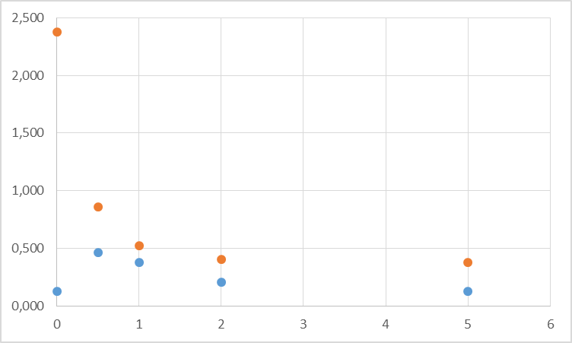
H2(s) = 0,970/(s + 1,219) - 0,970/(s + 3,281)
H2(t) = 0,970*exp(-1,219*t)-0,970*exp(-3,281*t)

t | H1 | h1 | H2 | h2
0 | 2,000 | 2,375 | 0,000 | 0,125
0,5 | 0,483 | 0,858 | 0,339 | 0,464
1 | 0,146 | 0,521 | 0,250 | 0,375
2 | 0,026 | 0,401 | 0,083 | 0,208
5 | 0,001 | 0,376 | 0,002 | 0,127

