**EQUIPMENT**

****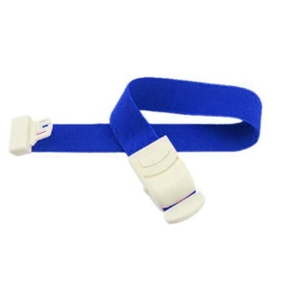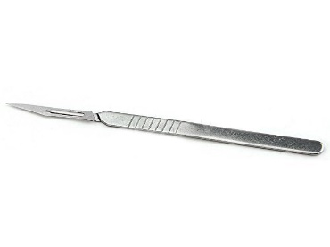

1. **2. 3.**



**4. 5. 6.**

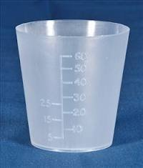

**7. 8. 9.**

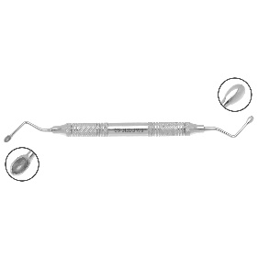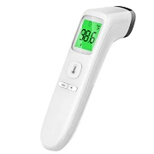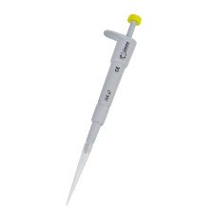

**10. 11. 12.**

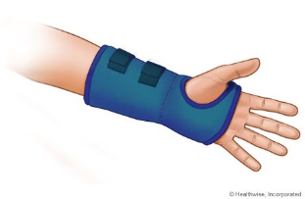

**13. 14. 15.**

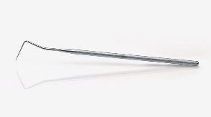

**16. 17. 18.**

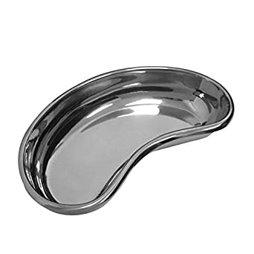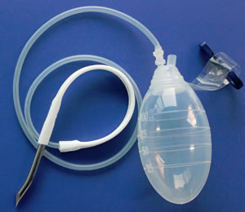

**19. 20. 21.**

[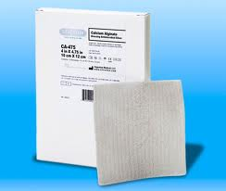](http://www.google.gr/imgres?start=189&hl=el&rls=com.microsoft:el:IE-SearchBox&rlz=1I7WZPA_enGR327&biw=1016&bih=584&tbm=isch&tbnid=BA3piBwiHC_siM:&imgrefurl=http://www.silverlon.com/Alginate_Dressings_Guidelines.html&docid=RfZJUpIDcXru3M&imgurl=http://silverlon.com/images/2010_pics/CA_Dressing_475_520_400.jpg&w=520&h=440&ei=pOVyT-zIGsPj4QT5v8CNDw&zoom=1)

**22. 23. 24.**

[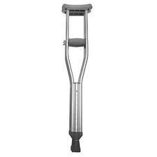](http://www.google.gr/imgres?hl=el&rls=com.microsoft:el:IE-SearchBox&rlz=1I7WZPA_enGR327&biw=1016&bih=584&tbm=isch&tbnid=dDvTbDhkMxmtKM:&imgrefurl=http://www.giantbomb.com/crutch/93-2655/&docid=4dody1oLn1s4QM&imgurl=http://media.giantbomb.com/uploads/1/13307/1099870-crutch_large.jpg&w=300&h=300&ei=jeZyT76FC7PP4QTD2LjJDw&zoom=1)[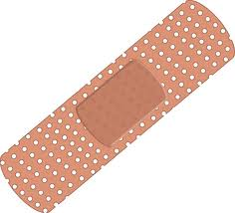](http://www.google.gr/imgres?hl=el&rls=com.microsoft:el:IE-SearchBox&rlz=1I7WZPA_enGR327&biw=1016&bih=584&tbm=isch&tbnid=9WNh1PMaQEIm7M:&imgrefurl=http://wpoprovider.com/%3Fattachment_id%3D146&docid=fWSnO-huKhAZIM&imgurl=http://wpoprovider.com/wp-content/uploads/2011/01/adhesive-bandage.jpg&w=500&h=453&ei=-ulyT7fkJcHb4QSaiaWCDw&zoom=1)

**25. 26.**