The Global Challenge of Obesity and the International Obesity Task Force

The Global Challenge of Obesity and the International Obesity Task Force
IOTF Secretariat

1. Introduction
Obesity is increasing at an alarming rate throughout the world. Today it is estimated that there are more than 300 million obese people world-wide. (http://www.who.int/nut/obs.htm) Obesity is defined as a condition of excess body fat and is associated with a large number of debilitating and life-threatening disorders.

2. Classification of obesity
As the direct measurement of body fat is difficult, Body Mass Index (BMI), a simple weight to height ratio (kg/m2), is typically used to classify overweight and obese adults. Consistent with this, the World Health Organization (WHO) has recently published international standards for classifying overweight and obesity in adults (Table 1). Obesity is defined as a BMI ³ 30 kg/m2, but can be further sub-divided on the bases of the severity of the obesity.
Although BMI provides a simple, convenient measurement of obesity, a more important aspect of obesity is the regional distribution of excess body fat. Mortality and morbidity vary with the distribution of body fat, with the highest risk linked to excessive abdominal fat (‘central obesity’). Central obesity is related to a number of diseases, including cardiovascular disease (CVD) and non-insulin dependent diabetes mellitus (NIDDM). The importance of central obesity is clear in populations (e.g. Asian) who tend to have relatively low BMIs but high levels of abdominal fat, and are particularly prone to NIDDM, hypertension and coronary heart disease (CHD). An Indian Study recently revealed that almost 20% of adults who were not overweight or obese still had central obesity, putting them at a greater risk of developing these associated diseases (Gopalan 1998). Additional methods to measure abdominal fat exist, such as waist circumference and waist to hip ratios (WHR) but unlike BMI these tend not to be taken routinely. Changes in waist circumference reflect changes in risk for CVD and other chronic diseases. As with BMI cut-off values have been set to identified increased risk, but for waist circumference these need to be sex and population specific (see Table 2). As the risk varies single global values can not be used.

3. The global epidemic of obesity
The prevalence of obesity is increasing in most part of the world, affecting men, women and children. Furthermore, obesity is no longer just a concern for developed countries, but it is becoming an increasing problem in many developing countries.

3.1. Prevalence of obesity
It should be noted that it is often difficult to make a direct comparison of the prevalence of obesity between countries due to the inconsistent classifications used for obesity. This problem may be overcome with the adoption of the WHO standardised classification for obesity, in future surveys. From available data, the world-wide prevalence of obesity has been found to range from less than 5% in rural China, Japan and some African countries to levels as high as 75% of the adult population in urban Samoa. Figure 1 provides examples of the varying prevalence of obesity within different countries. Obesity levels also vary depending on ethnic origin. In the USA, particularly among women, there are large differences in the prevalence of obesity between populations of the different ethnic origins within the same country.
The growing prevalence of obesity among children is also a major concern (Table 3). The lack of agreement in defining obesity in children and adolescents has made it difficult to estimate the true prevalence. The International Obesity Task Force (IOTF) developed a new approach to defining childhood overweight and obesity to make it consistent with the adult definition. (http://bmj.com/cgi/content/abridged/320/7244/1240) However, using existing WHO standards, data from 79 developing countries and a number of industrialised countries suggests that about 22 million children under 5 years old are overweight world-wide (WHO 1998). There is also evidence that this problem is increasing; in the USA, the percentage of overweight children (aged 5-14 years) has doubled in the last 30 years, from 15% to 32%.

3.2. Trends and projections
Many countries have experienced a startling increase in obesity rates over the last 10-20 years (Figure 2). Over the past decade levels have increased on average between 10-40% (Seidell & Flegal 1997). In England the prevalence of obesity has doubled since 1980. Based on current trends, it is predicted that the levels of obesity will continue to rise unless action is taken now. The WHO recently stated "the growth in the number of severely overweight adults is expected to be double that of underweight during 1995-2025" (WHO 1998). Crude projections, from extrapolating existing data, suggest that by the year 2025 levels of obesity could be as high as 45-50% in the USA, between 30-40% in Australia, England and Mauritius and over 20% in Brazil (Figure 3).

3.3. Key patterns associated with obesity
A number of factors have been linked to obesity, including age, gender and socio-economic status. In developed countries the natural pattern with age is an increase in body weight with ageing, at least up to 50-60 years old (in both men and women). The relationship between obesity and age is similar in developing countries, but the maximum rates of obesity tend to be reached at an earlier age (e.g. 40 years old). The decline in prevalence after this peak is thought to be partly attributed to lower survival rate of obese individuals. Clear gender difference are seen in most countries with more women than men being obese (BMI ³ 30). In contrast, the proportion of men who are overweight (BMI 25.0-29.9) tends to be greater than women (Figure 4). Patterns have also emerged across socio-economic groups. In developed countries levels of obesity are higher in the lower socio-economic groups. In developing countries this relationship is reversed. The transition from a rural to an urban lifestyle is associated with increased levels of obesity, which has been linked with dramatic changes in lifestyles (e.g. increased consumption of high energy dense foods and decrease in physical activity). As stated in section 3.1 ethnicity is also thought to be feature associated with the variation in levels of obesity.

3.4. Health, social and economic costs of obesity
Obesity has a great number of negative health, social and economic consequences. Mortality and morbidity rates are higher among overweight and obese individuals than lean people. Increased BMI is linked with a greater risk of CHD, hypertension, hyperlipidaemia (Figure 5), NIDDM and certain cancers. Furthermore, obesity has been recently identified as a major independent risk factor for CHD by the American Heart Association (1997). Modest weight reduction can significantly reduce the risk of these serious health conditions. In addition to the physical consequences on health, obesity creates a massive social burden. Obesity has been described as the "last remaining socially acceptable form of prejudice" (Stunkard & Sobal 1995, p 417). This prejudice does not only exist among the general public but also among the majority of health care professionals. Negative attitudes of health care professionals can seriously impede the treatment of overweight and obese patients.
Often over shadowed by the health and social consequences of obesity is the economic cost to society and to the individual. In 1995, for example, in the USA the total economic cost attributable to obesity was estimated at $99 billion (Wolf & Colditz 1998). In several developed countries obesity has been estimated to account for 2-7% of the total health care costs (WHO TRS 894). In addition to the direct costs of obesity are costs in terms of the individuals (including ill health and reduced quality of life (intangible costs)) and society in terms of loss of productivity due to sick-leave and premature pensions (indirect costs). Prevention is clearly more cost effective than treatment, both in terms of economic and personal costs. Health care providers and policy makers need to appreciate the importance of obesity and its prevention, and develop effective polices and programmes to prevent obesity.

4. The need for ACTION
Obesity is a serious medical condition which needs urgent attention throughout the world. The International Obesity Task Force (IOTF) was established in May 1996 to tackle the emerging global epidemic of obesity (http://www.iotf.org).

4.1. What is the IOTF?
The IOTF is a part of the International Association for the Study of Obesity (IASO), an organisation that represents 43 National Obesity Associations across the globe (http://www.iaso.org). The Task Force is composed of world experts in the field of obesity and related diseases from around world, including China, Japan, Chile, Australia, Brazil, the USA, Canada and Europe. IASO is an NGO in formal relations with WHO. The IOTF collaborates closely with the WHO and is engaged with other international health organisations, including the Commonwealth, and national governments to raise awareness and help develop solutions to the global epidemic of obesity. The secretariat for the IOTF is based at 231 North Gower Street, London NW1 2NS England. (Figure 6).

4.2. The IOTF Initiative
The IOTF initiative on the prevention and management of obesity has four main goals:
1. To increase the awareness among governments, health care professionals and the community that obesity is a serious medical condition and a major health problem with substantial economic costs.
2. To provide evidence and guidance for the development of better prevention and management strategies.
3. To secure the commitment of policy makers to action
4. To foster the development of national, regional and international structures that will enable and support the implementation of action on overweight and obesity.

4.3. WHO consultation report on obesity
In June 1997 the WHO, together with the IOTF, held an expert consultation on obesity to review the extent of the obesity problem and examine the need to develop public health policies and programmes to tackle the global problem of obesity. The consultation resulted in the publication of an interim report: "Obesity - preventing and managing the global epidemic" (WHO 1998) and the subsequent WHO Technical Report Series 894.

4.4. What is the IOTF doing to tackle the obesity problem?
The IOTF aims to achieve action on the prevention and management of overweight and obesity and endeavours to create an environment that encourages and supports the development of appropriate public and health polices and programmes for prevention and management of obesity.
A small number of countries have started to address the problem, but it will take time for strategies to be implemented, then time before results are seen. In Brazil, for example, significant commitment has been recently made to tackling the growing problem of obesity. In many countries individuals cannot get treatment for obesity because it is not recognised by health insurance companies as a reimbursable condition. Australia is an example of a country taking action; in 1995 the government convened a working party of the National Health and Medical Research Council on the Prevention of Obesity. Their principal strategy is prevention through changing the environment in such a way to make it less ’obesogenic’ to the individual, thus incorporating the whole community. The focus has been on how to tackle childhood obesity now a major issue in many parts of the world.
One country to have strong commitments to reduce the prevalence of overweight and obesity is Singapore. Since it introduced the ‘Fit and Trim’ programme into schools levels of obesity in primary, secondary and junior college students has reduced and fitness improved. The programme is based on activities promoting healthy eating habits and increased physical activity. Allowing for cultural differences between countries, the extent lessons can be learnt from this programme remains to be seen.

4.5. Areas requiring further exploration
The IOTF has identified a number of areas where our understanding of overweight and obesity needs to be improved. Specific working groups have examined the following issues:
Childhood Obesity
Economic Costs of Obesity
Management of Obesity
Public health Approaches to the Prevention of Obesity (PHAPO)
Training of Health Professionals
Subsequently groups have been or are in the process of being reformed on:
Childhood Obesity - linking a regional group network and establishing a global agenda
Management of Obesity - developing novel approaches to management
Prevention Reference Group - assessing current interventions and proposing measures needed to transform the "obesogenic" environment
Economics Group - assessing the impact of obesity in terms of direct health costs, indirect costs, years of life lost as well as disability and qualify of life lost.
Steering Group - oversight of IOTF policy
The results from these groups will enable policies and programmes for the prevention and management of obesity to be developed, improved and implemented.

5. References
Cole TJ, Bellizzi MC, Flegal KM, Dietz WH. Establishing a standard definition for child overweight and obesity worldwide: international survey BMJ 2000;320:1240-1243 ( 6 May )
Gopalan C. Obesity in the Indian Urban 'Middle Class'. Bulletin of the Nutrition Foundation of India 1998;19(1):1-5.
Popkin BM, Richards MK, Montiero CA (1996) Stunting is associated with overweight in children of four nations that are undergoing the nutrition transition. Journal of Nutrition, 126, 3006-3016.
Seidell JC & Flegal KM (1997) Assessing obesity: classification and epidemiology. In: Obesity, British Medical Bulletin, 53, 2, 238-252.
Stunkard AJ & Sobal J (1995) Psychological consequences of obesity. In: Eating disorders and obesity: a comprehensive handbook. Ed: Brownell KD & Fairburn CG, The Guildford Press, New York.
Wolf AM & Colditz GA, (1998) Current estimates of economic costs of obesity in the United States. Obes Res, 6 (2) 97-106.
WHO (1998) World Health Report, Life in the 21st century: A vision for all. Geneva (p 132).
WHO TRS 894 "Obesity - preventing and managing the global epidemic".
(Prepared by Jennie Macdiarmid, September 1998, revised provisionally by Neville Rigby Oct 2002)
For further information concerning the International Obesity Task Force please contact:
International Obesity Task Force
231 North Gower Street
London NW1 2NS
UK
Phone: +44 {0} 20 7691 1900
Fax: + 44 {0} 20 7387 6033
URL: www.iotf.org
Inquiries: obesity@iotf.org

Tables

Table 1: WHO standard classification of obesity
 | BMI | Risk of co-morbidities
Normal BMI | 18.5-24.9 | average
Overweight:
Pre-obese | 25.0-29.9 | increased
Obesity class I | 30.0-34.9 | moderate
Obesity class II | 35.0-39.9 | severe
Obesity class III | ≥ 40 | very severe
(WHO 1997)

Table 2: Sex-specific waist circumferences for ‘increased risk’ and ‘substantially increased risk’ of metabolic complications associated with obesity in Caucasians
 | Risk of obesity-associated metabolic complications
 | Increased | Substantially increased
Men | ≥ 94 cm | ≥ 102 cm
Women | ≥ 80 cm | ≥ 88 cm
Note: The figure are population-specific and the relative risk also depends on levels of obesity (BMI) and other risk factors for CVD and NIDDM) (WHO report 1997)

Table 3: Prevalence of overweight* children aged 6 to 8 year old
 | USA  1988-91 | China  1993 | Russia  1994-5 | South Africa  1994 | Brazil  1989
Girls | 24.2 | 12.2 | 17.8 | 20.3 | 10.5
Boys | 21.3 | 14.1 | 25.6 | 25.0 | 12.8
Popkin et al 1996
(*defined as BMI higher than the US reference NHES 85th percentile)

Figures

Figure 1: Examples of the prevalence of obesity in adults throughout the world
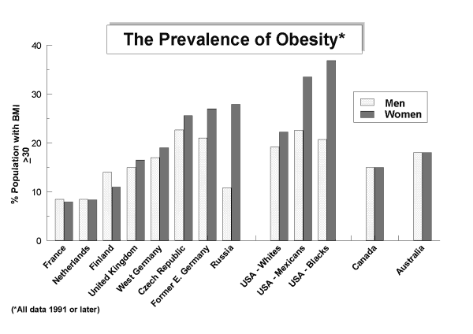

Figure 2: The increasing prevalence of obesity in adults world-wide.
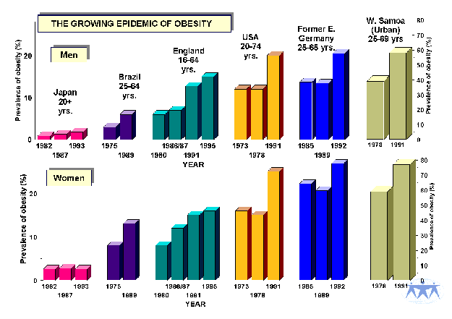

Figure 3: Projected prevalence of obesity in adults by 2025
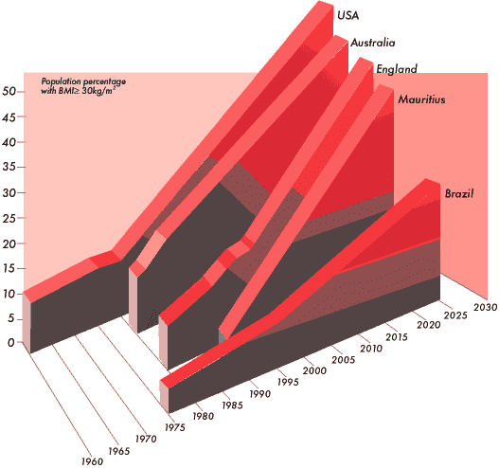

Figure 4: BMI distributions: proportion of men and women classified as obese, overweight and normal weight.
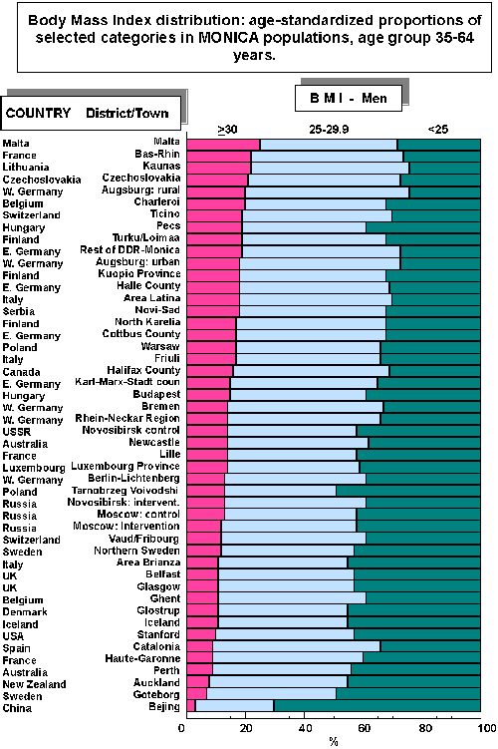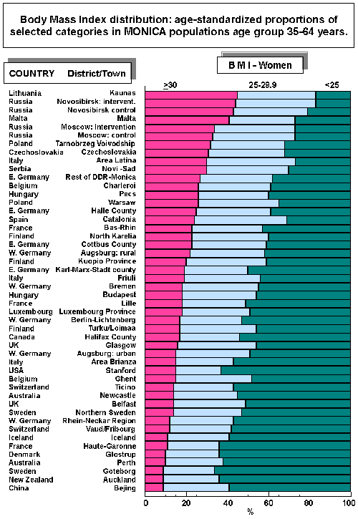
Note: Age standardised proportions from MONICA populations (age 35-64 years), data collected 1983-1986.

Figure 5: Relationship between BMI and cardiovascular risk factors
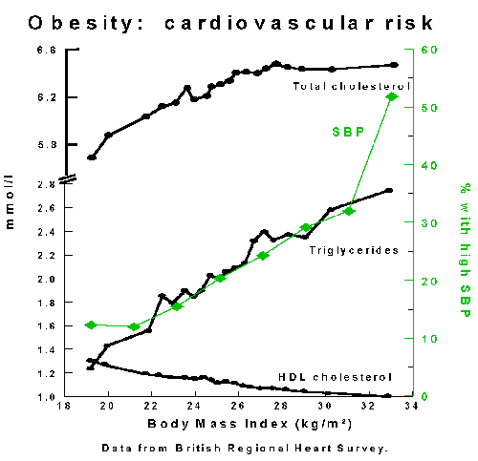

Figure 6: The organisational structure of the IOTF
