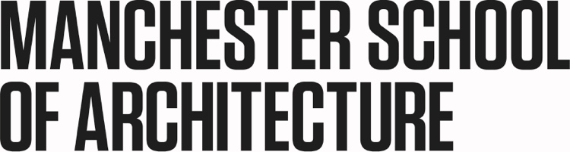

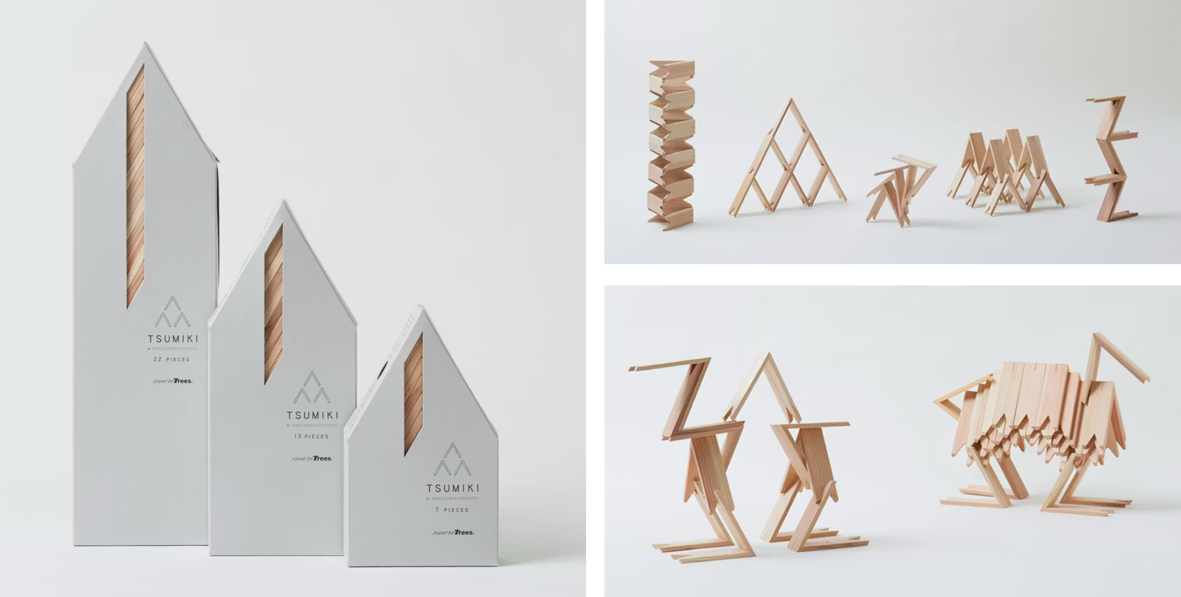

Image : Tsumiki by Studio Kengo Kuma.

Play Culture : Exploring matters of personal and collective identity through creating, playing and making together.

The objects of our production not only address practical needs but they also represent aspects of our culture and identity. The materials, connections, methods of shaping and decoration all express something of the individual or community who made them. This workshop will be an opportunity to explore matters of personal and collective identity through making together. In small groups, participants will be invited to make a prototype for play which can be physical (a toy) or non-tangible (a game). The design should respond to the cultural values, traditions and identity of its group members.

In the first workshop, students from Manchester School of Architecture will be invited to explore ideas of individual and collective identity. They will design and produce an initial prototype which represents aspects of the group members’ individual and cultural identities.

In our second workshop, students will share their prototypes in an online presentation to international student collaborators from universities in Germany, Greece and India. Our international collaborators will be invited to reflect on how differences in culture might have influenced the design in their own setting. Through international online collaboration students will produce a second prototype which reflects the cultural frameworks of the international group.

Session times:
Workshop (MSA Students) : 10:00 – 15:00h (GMT), Thursday 26 February 2026.
International presentations and workshop (Online) : 09:00 – 13:00h, Tuesday 17 March.

Organiser: John Wood, Lecturer, BA2 deputy cohort lead, Manchester School of Architecture.
john.wood@mmu.ac.uk

