1^{η} Πρόοδος Δυναμική και Έλεγχος Διεργασιών 14 Νοεμβρίου 2017
ΘΕΜΑ1 (10μονάδες)
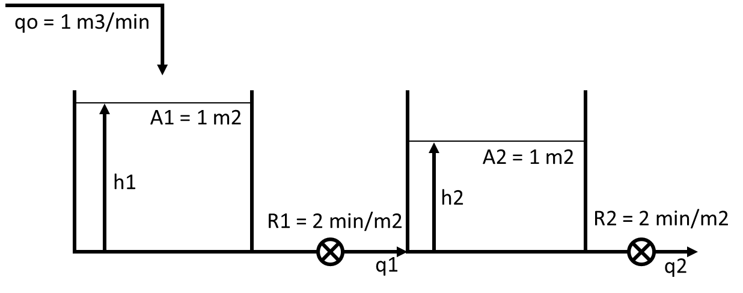
Σε χρόνο 0 προστίθεται στιγμιαία 1 m3. Να υπολογιστεί και να παρασταθεί γραφικά (σε χρόνο 0, 1, 5, 10, 20, 30 min) η απόκριση της στάθμης στην 1^{η} και τη 2^{η} δεξαμενή.

@SS 1 – (h1s – h2s)/2 = 0 (h1s – h2s) = 2 h1s = 4
(h1s – h2s)/2 – h2s/2 = 0 h2s = 2

Ισοζύγιο μάζας στην 1^{η} δεξαμενή
qo(t) – (h1(t) – h2(t))/R1 = A1*dh1(t)/dt Qo(t) – H1(t)/2 + H2(t)/2 = 1*dH1(t)/dt
2*Qo(t) – H1(t) + H2(t) = 2*dH1(t)/dt 2Qo(s) – H1(s) + H2(s) = 2sH1(s) (1)

Ισοζύγιο μάζας στην 2^{η} δεξαμενή
(h1(t) – h2(t))/R1 – h2(t)/R2 = A2*dh2(t)/dt h1(t)/2 – h2(t)/2 – h2(t)/2 = 1*dh2(t)/dt
h1(t) – 2*h2(t) = 2*dh2(t)/dt H1(t) – 2*H2(t) = 2dH2(t)/dt H1(s) – 2H2(s) = 2sH2(s)
H1(s) = (2s + 2)H2(s) H2(s) = H1(s)/(2s + 2)

(1) 2Qo(s) – H1(s) + H1(s)/(2s + 2) = 2sH1(s) 2Qo/H1 – 1 + 1/(2s + 2) = 2s Qo/H1 = s – 0,5/(2s + 2) + 0,5
Qo/H1 = (2s2 + 2s – 0,5 + s + 1)/(2s + 2) H1/Qo = (2s + 2)/(2s2 + 3s + 0,5)
H1/Qo = 2s/(2s2 + 3s + 0,5) + 2/(2s2 + 3s + 0,5)

(1) 2Qo(s) – (2s + 2)H2(s) + H2(s) = 2s(2s + 2)H2(s) 2Qo/H2 = (2s + 2) – 1 + 2s(2s + 2)
Qo/H2 = s + 1 – 0,5 + 2s2 + 2s = 2s2 + 3s + 0,5 H2/Qo = 1/(2s2 + 3s + 0,5)

Κρουστική διαταραχή της παροχής: qo(t) = qos + δ(t) qo(t) – qos = δ(t) Qo(t) = δ(t) Qo(s) = 1

Λύση τριωνύμου Δ = 9-4*2*0,5 = 5 x1 = (-3+5^0,5)/4 = -0,191 x2 = (-3-5^0,5)/4 = -1,309
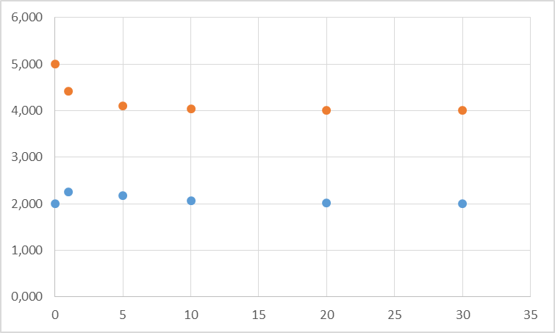
HEAVYSIDE
2s/2(s + 0,191)(s + 1,309) = A/(s + 0,191) + B/(s + 1,309)
A = (-0,191)/(-0,191+1,309) = -0,171
B = (-1,309)/(-1,309+0,191) = 1,171

1/2(s + 0,191)(s + 1,309) = Γ/(s + 0,191) + E/(s + 1,309)
Γ = 0,5/(-0,191+1,309) = 0,447
E =0,5/(-1,309+0,191) = -0,447

H1 = -0,171/(s + 0,191) + 1,171/(s + 1,309) + 0,894/(s + 0,191) - 0,894/(s + 1,309)
H1(t) = 1,171*exp(-1,309*t)+0,894*exp(-0,191*t)-0,171*exp(-0,191*t)-0,894*exp(-1,309*t)

H2 = 0,447/(s + 0,191) - 0,447/(s + 1,309) H2(t) = 0,447*exp(-0,191*t)-0,447*exp(-1,309*t)

t | H1 | h1 | H2 | h2 | t | H1 | h1 | H2 | h2
0 | 1,000 | 5,000 | 0,000 | 2,000 | 10 | 0,041 | 4,041 | 0,066 | 2,066
1 | 0,424 | 4,424 | 0,249 | 2,249 | 20 | 0,006 | 4,006 | 0,010 | 2,010
5 | 0,107 | 4,107 | 0,171 | 2,171 | 30 | 0,001 | 4,001 | 0,001 | 2,001

ΘΕΜΑ 2 (10 μονάδες)
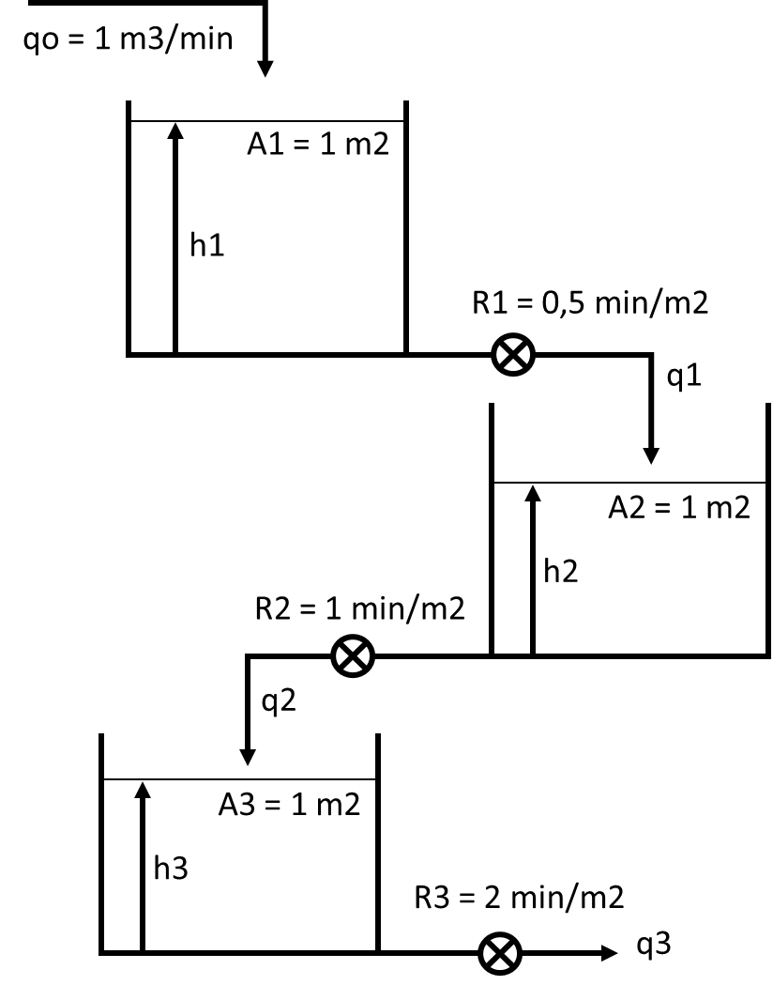
Στο σύστημα δεξαμενών η παροχή αυξάνεται βηματικά κατά 1 m3/min, για 5 λεπτά και στη συνέχεια ελαττώνεται στην αρχική της τιμή. Να υπολογιστεί η στάθμη των τριών δεξαμενών σε χρόνο 4 και 6 λεπτά.

Βηματική μεταβολή της qo: qo(t) = qos + 1u(t) – 1u(t-5) qo(t) – qos = 1u(t) – 1u(t-5)
Qo(t) = 1u(t) – 1u(t-5) Qo(s) = 1/s – exp(-5s)/s

Ισοζύγιο μάζας στην 1^{η} δεξαμενή
@SS 1 – h1s/0,5 = 0 h1s = 0,5

qo(t) – h1(t)/R1 = A1*dh1(t)/dt Qo(t) – H1(t)/0,5 = 1*dH1(t)/dt
0,5*Qo(t) – H1(t) = 0,5*dH1(t)/dt 0,5Qo(s) – H1(s) = 0,5sH1(s)
0,5 – Η1/Qo = 0,5sH1/Qo H1/Qo*(0,5s + 1) = 0,5 H1/Qo = 1/(s + 2) (1)
H1 = 1/s(s + 2) – exp(-5s)/s(s +2) (2)

HEAVYSIDE 1/s(s + 2) = A/s + B/(s + 2) A = 0,5 B = -0,5

(2) H1 = 0,5/s – 0,5/(s + 2) – 0,5*exp(-5s)/s + 0,5*exp(-5s)/(s + 2)
H1(t) = 0,5*(1 – exp(-2t))*u(t) - 0,5*(1-exp(-2*(t-5)))*u(t-5)

H1(4) = 0,5*(1 – exp(-2*4)) = 0,50 m h1(4) = 0,50+0,50 = 1 m
H1(6) = 0,5*(1 – exp(-2*6))-0,5*(1-exp(-2*(6-5))) = 0,07 h1(6) = 0,50+0,07 = 0,57 m

q1(t) = h1(t)/R1 Q1(t) = H1(t)/0,5 Q1(s) = H1(s)/0,5 H1 = 0,5Q1

(1) 0,5Q1/Qo = 1/(s + 2) Q1/Qo = 2/(s + 2)

Ισοζύγιο μάζας στην 2^{η} δεξαμενή q1(t) – h2(t)/R2 = A1*dh2(t)/dt Q1(t) – H2(t)/1 = 1*dH2(t)/dt
@SS 1 – h2s/1 = 0 h2s = 1 Q1(s) – H2(s) = sH2(s) 1 – Η2/Q1 = sH2/Q1
H2/Q1*(s + 1) = 1 H2/Q1 = 1/(s + 1) (3)

H2/Qo = (H2/Q1)*(Q1/Qo) = (1/(s + 1))*(2/(s + 2)) = 2/(s + 1)(s + 2)

H2 = 1/s(s + 1)(s + 2) – exp(-5s)/s(s + 1)(s +2) (4)

HEAVYSIDE 1/s(s + 1)(s + 2) = A/s + B/(s + 1) + C/(s + 2) A = 0,5 B = -1 C = 1/(-2)((-1) = 0,5

(4) H2 = 0,5/s + 0,5/(s + 2) – 1/(s + 1) – 0,5*exp(-5s)/s – 0,5*exp(-5s)/(s + 2) + 0,5*exp(-5s)/(s + 1)
H2(t) = 0,5*(1+exp(-2*t)-2*exp(-t))*u(t) – 0,5*(1+exp(-2(t-5))-exp(-(t-5)))*u(t-5)

H2(4) = 0,5*(1+exp(-2*4)-2*exp(-4)) = 0,48 m h2(4) = 1,0+0,48 = 1,48 m
H2(6) = 0,5*(1+exp(-2*6)-2*exp(-6))-0,5*(1+exp(-2*(6-5))-2*exp(-(6-5))) = 0,30 m h2(6) = 1,0+0,30 = 1,30 m

q2(t) = h2(t)/R2 Q2(t) = H2(t)/1 Q2(s) = H2(s)

(3) Q2/Q1 = 1/(s + 1)

Ισοζύγιο μάζας στην 3^{η} δεξαμενή q2(t) – h3(t)/R3 = A3*dh3(t)/dt Q2(t) – H3(t)/2 = 1*dH3(t)/dt
@SS 1 – h3s/2 = 0 h3s = 2 2Q2(s) – H3(s) = 2sH3(s) 2 – Η3/Q2 = sH3/Q2
H3/Q2*(s + 1) = 2 H3/Q2 = 2/(s + 1)

H3/Qo = (H3/Q2)*(Q2/Q1)*(Q1/Qo) = (2/(s + 1))*(1/(s + 1))*(2/(s + 2)) = 4/(s + 1)(s + 1)(s + 2)

H3 = 4/s(s + 1)²(s + 2) – 4exp(-5s)/s(s + 1)²(s +2) (5)

HEAVYSIDE 4/s(s + 1)²(s + 2) = A/s + B/(s + 1)² + C/(s + 1) + D/(s + 2)
A = 4/(1)(2) = 2 B = 4/(-1)(1) = -4 D = 4/(-2)(1) = -2
4/s(s + 1)²(s + 2) = 2/s – 4/(s + 1)² + C/(s + 1) – 2/(s + 2) 4 = 2(s + 1)²(s + 2) – 4s(s + 2) + Cs(s + 1)(s + 2) – 2s(s + 1)² =
= 2(s2 + 2s + 1)(s + 2) – 4s2 – 8s + C(s2 + s)(s + 2) – 2s(s2 + 2s + 1) =
= 2(s3 + 2s2 + s + 2s2 + 4s + 2) - 4s2 - 8s + C(s3 + s2 + 2s2 + 2s) – 2s3 – 4s2 – 2s =
= 2s3 + 4s2 + 2s + 4s2+ 8s + 4 - 4s2 - 8s + Cs3 + Cs2 + 2Cs2 + 2Cs – 2s3 – 4s2 – 2s
s3(2 + C – 2) + s2(4 + 4 - 4 + C + 2C – 4) + s(2 + 8 - 8 + 2C – 2) = 0 C = 0

(5) H3 = 4/s – 4/(s + 1)² – 2/(s + 2) – 4*exp(-5s)/s + 4*exp(-5s)/(s + 1)² + 2*exp(-5s)/(s + 2)
H3(t) = 4*(1 + t*exp(-t)-0,5*exp(-2t))*u(t) – 4*(1 + (t-5)*exp(-(t-5))-0,5*exp(-2(t-5)))*u(t-5)

H3(4) = 4*(1 + 4*exp(-4)-0,5*exp(-2*4)) = 4,29 m h3(4) = 2,0+4,29 = 5,29 m
H3(6) = 4*(1+6*exp(-6)-0,5*exp(-2*6))-4*(1+(6-5)*exp(-(6-5))-0,5*exp(-2*(6-5))) = -1,14 m h3(6) = 2,0-1,14 = 0,86 m

ΘΕΜΑ 3 (10 μονάδες)
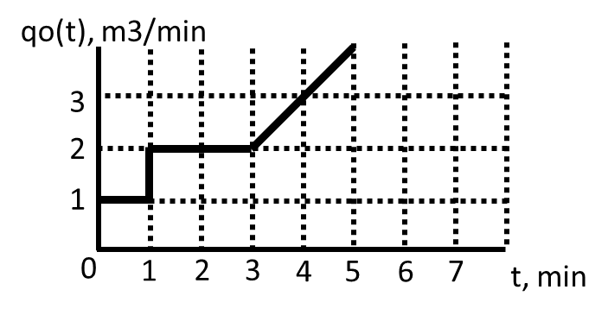
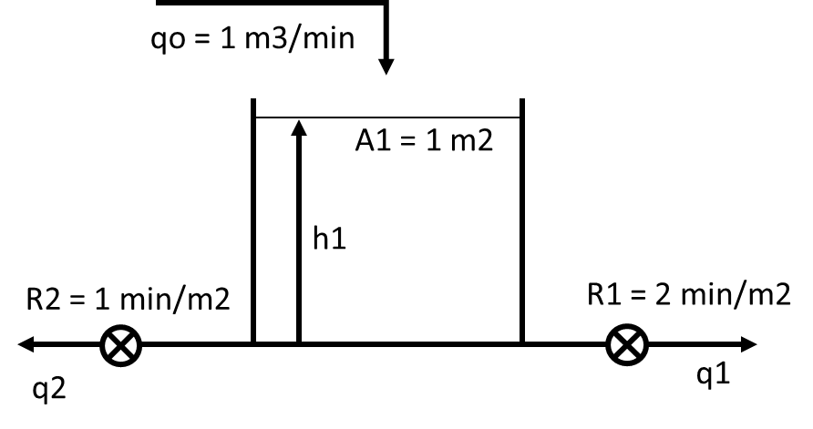
Στη δεξαμενή επιβάλλεται η μεταβολή του σχήματος. Να υπολογιστεί η στάθμη στο 2^{ο}, 3^{ο}, 4^{ο} και 5^{ο} λεπτό.

Ισοζύγιο μάζας: @SS 1 – hs – hs/2 = 0 1 = 3hs/2 hs = 2/3
q(t) – h(t)/R1 – h(t)/R2 = Adh(t)/dt Q(t) – H(t)/2 – H(t) = dH(t)/dt Q(s) – 3/2H(s) = sH(s)
1 – 1,5H/Q = sH/Q 1 = H/Q(s + 1,5) H/Q = 1/(s + 1,5) (1)

q(t) = qs + 1*u(t) + t*u(t-2) q(t) - qs = 1*u(t) + t*u(t-2) Q(t) = 1*u(t) + t*u(t-2) Q(s) = 1/s + exp(-2s)/s2

(1) H = 1/s(s + 1,5) + exp(-2s)/s2(s + 1,5) (2)

HEAVYSIDE: 1/s(s + 1,5) = A/s + B/(s + 1,5) = (2/3)/s – (2/3)/(s + 1,5)
1/s2(s + 1,5) = C/s2 + D/s + E/(s + 1,5) C = 2/3 E = 1/(-3/2)^2 = 1/(9/4) = 4/9
1 = (2/3)*(s + 3/2) + D*s*(s + 3/2) + (4/9)*s2 = (2/3)s + 1 + D*s2 + (3D/2)s + (4/9)*s2
D = -4/9 2/3 = - 3D/2 D = -4/9

(2) H = (2/3)/s – (2/3)/(s + 1,5) + exp(-2s)[(2/3)/s2 – (4/9)/s + (4/9)/(s + 1,5)]
H(t) = 2/3 – (2/3)exp(-1,5t) + [(2/3)(t – 2) – (4/9) + (4/9)exp(-1,5(t-2))]u(t – 2)

H(2) = 2/3-(2/3)*exp(-1,5*1) = 0,52 h(2) = 0,67 + 0,52 =1,19 m
H(3) = 2/3-(2/3)*exp(-1,5*2) = 0,63 h(3) = 0,67 + 0,63 =1,30 m
H(4) = 2/3-(2/3)*exp(-1,5*3) + (2/3)*(3-2)-(4/9)+(4/9)*exp(-1,5*(3-2)) = 0,98 m h(4) = 0,67 + 0,98 =1,65 m
H(5) = 2/3-(2/3)*exp(-1,5*4) + (2/3)*(4-2)-(4/9)+(4/9)*exp(-1,5*(4-2)) = 1,58 m h(5) = 0,67 + 1,58 =2,24 m

