1^{η} Πρόοδος Δυναμική και Έλεγχος Διεργασιών 14 Νοεμβρίου 2017
ΘΕΜΑ 1 (10 μονάδες)
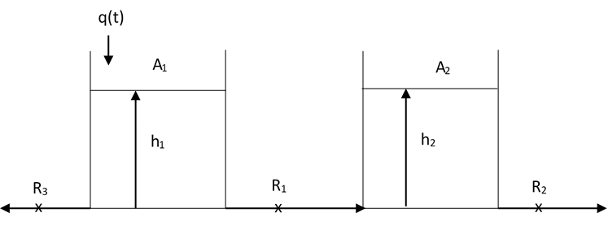
Σε χρόνο 0, προστίθενται στιγμιαία 2 m³. Να υπολογιστεί και να παρασταθεί γραφικά (σε χρόνο 0, 0,5, 1, 2 και 5 ώρες) η απόκριση της στάθμης στην 1^{η} και τη 2^{η} δεξαμενή. Οι αντιστάσεις είναι γραμμικές: R₁ = 1 και R₂ = R₃ = 0,5. Οι επιφάνειες των δεξαμενών είναι: Α₁ = 1 m² και A₂=2m². Σε μόνιμη κατάσταση η παροχή q_{s} = 1 m³/h.

@SS 1 – (h1s – h2s)/1 – h1s/0,5 = 0 0,5 – 0,5h1s + 0,5h2s – h1s = 0 0,5 = 1,5h1s – 0,5h2s (1)
(h1s – h2s)/1 – h2s/0,5 = 0 0,5h1s – 0,5h2s – h2s = 0 0,5h1s – 1,5h2s = 0 h1s = 3h2s (2)

- 4,5h2s – 0,5h2s = 0,5 4h2s = 0,5 h2s = 0,125 m
- h1s = 0,375

Ισοζύγιο μάζας στην 1^{η} δεξαμενή
qo(t) – (h1(t) – h2(t))/R1 – h1(t)/R3 = A1*dh1(t)/dt Qo(t) – H1(t) + H2(t) – H1(t)/0,5 = 1*dH1(t)/dt
0,5*Qo(t) – 1,5*H1(t) + 0,5*H2(t) = 0,5*dH1(t)/dt Qo(s) – 3*H1(s) + H2(s) = sH1(s) (3)

Ισοζύγιο μάζας στην 2^{η} δεξαμενή
(h1(t) – h2(t))/R1 – h2(t)/R2 = A2*dh2(t)/dt h1(t) – h2(t) – h2(t)/0,5 = 2*dh2(t)/dt 0,5*H1(t) – 1,5*H2(t) = dH2(t)/dt
0,5H1(s) – 1,5H2(s) = sH2(s) 0,5H1(s) = (s + 1,5)H2(s) H1(s) = (2s + 3)H2(s) H2(s) = 0,5H1(s)/(s + 1,5) (4)

(3) Qo(s) – 3H1(s) + 0,5H1(s)/(s + 1,5) = sH1(s) Qo/H1 – 3 + 0,5/(s + 1,5) = s Qo/H1 = s – 0,5/(s + 1,5) + 3
Qo/H1 = (s2 + 1,5s – 0,5 + 3s + 4,5)/(s + 1,5) H1/Qo = (s + 1,5)/(s2 + 4,5s + 4)
H1/Qo = s/(s2 + 4,5s + 4) + 1,5/( s2 + 4,5s + 4)

(3) Qo(s) – (6s + 9)H2(s) + H2(s) = s(2s + 3)H2(s) Qo/H2 – (6s +9) +1 = s(2s + 3) Qo/H2 = 6s + 9 – 1 + 2s2 + 3s
Qo/H2 = 2s2 + 9s +8 H2/Qo = 1/(s2 + 4,5s + 4)

Κρουστική διαταραχή της παροχής: qo(t) = qos + 2δ(t) qo(t) – qos = 2δ(t) Qo(t) = 2δ(t) Qo(s) = 2

Λύση τριωνύμου: Δ = 20,25-4*1*4 = 4,25 x1 = (-4,5+4,25^0,5)/2 = -1,219 x2 = (-4,5-4,25^0,5)/2 = -3,281

HEAVYSIDE
2s/(s + 1,219)(s + 3,281) = A/(s + 1,219) + B/(s + 3,281)
A = (-2*1,219)/(-1,219+3,281) = -1,182
B = (-2*3,281)/(-3,281+1,219) = 3,182

3/(s + 1,219)(s + 3,281) = Γ/(s + 1,219) + Ε/(s + 3,281) 2/(s + 1,219)(s + 3,281) = Z/(s + 1,219) + H/(s + 3,281)
Γ = 3/(-1,219+3,281) = 1,455 Z = 1/(-1,219+3,281) = 0,970
E = 3/(-3,281+1,219) = -1,455 H = 1/(-3,281+1,219) = -0,970

H1(s) = -1,182/(s + 1,219) + 3,182/(s + 3,281) + 1,455/(s + 1,219) – 1,455/(s + 3,281) = 0,273/(s + 1,219) + 1,727/(s + 3,281)
H1(t) = 0,273*exp(-1,219*t)+1,727*exp(-3,281*t)
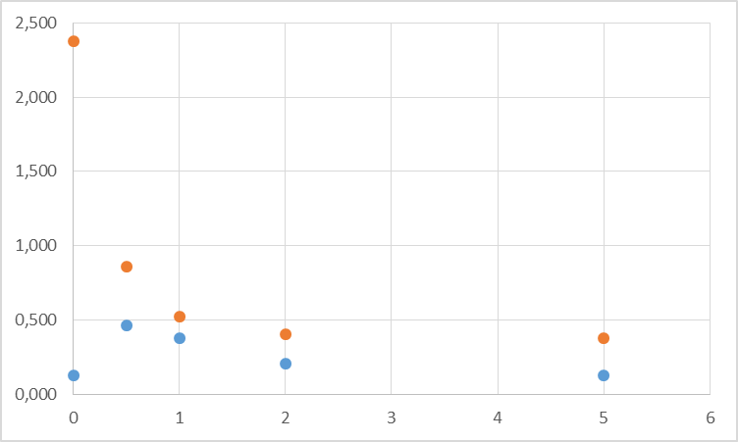
H2(s) = 0,970/(s + 1,219) - 0,970/(s + 3,281)
H2(t) = 0,970*exp(-1,219*t)-0,970*exp(-3,281*t)

t | H1 | h1 | H2 | h2
0 | 2,000 | 2,375 | 0,000 | 0,125
0,5 | 0,483 | 0,858 | 0,339 | 0,464
1 | 0,146 | 0,521 | 0,250 | 0,375
2 | 0,026 | 0,401 | 0,083 | 0,208
5 | 0,001 | 0,376 | 0,002 | 0,127

ΘΕΜΑ2 (10μονάδες)
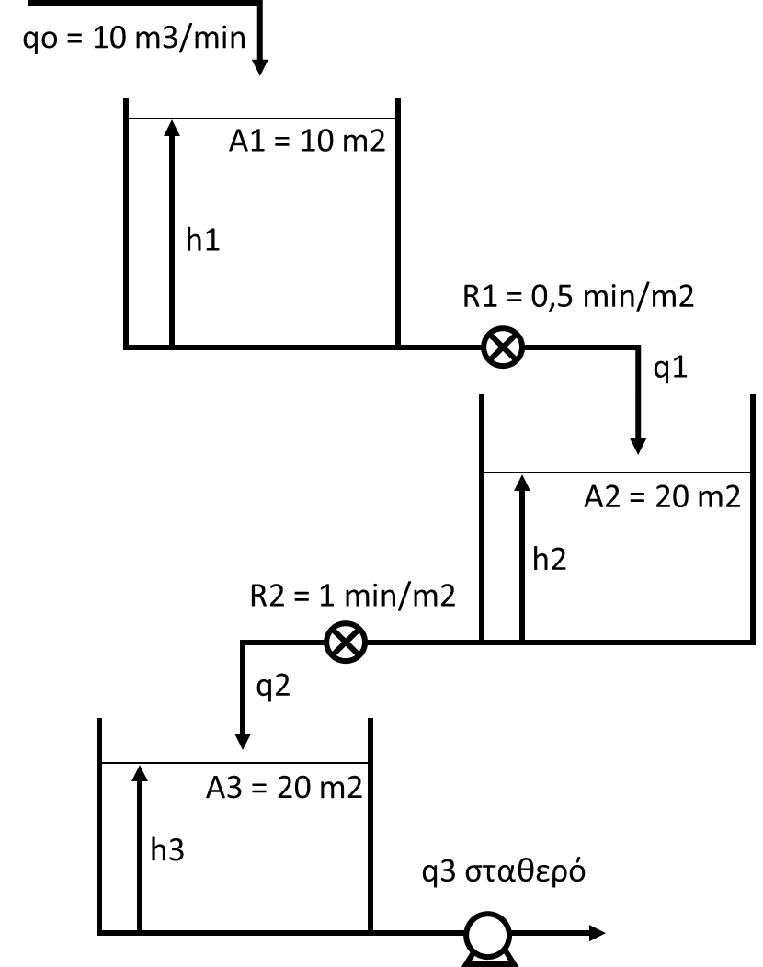
Στο σύστημα δεξαμενών η παροχή αυξάνεται με ρυθμό 1 m3/min. Να υπολογιστεί η στάθμη των τριών δεξαμενών σε χρόνο 1 και 5 λεπτά.

ΧΩΡΙΣ ΤΡΙΤΗ ΔΕΞΑΜΕΝΗ

Γραμμική μεταβολή της qo: qo(t) = qos + t*u(t) qo(t) – qos = t*u(t)
Qo(t) = t*u(t) Qo(s) = 1/s2

Ισοζύγιο μάζας στην 1^{η} δεξαμενή
@SS 10 – h1s/0,5 = 0 h1s = 5

qo(t) – h1(t)/R1 = A1*dh1(t)/dt Qo(t) – H1(t)/0,5 = 10*dH1(t)/dt
0,5*Qo(t) – H1(t) = 5*dH1(t)/dt 0,5Qo(s) – H1(s) = 5sH1(s) 0,5 – Η1/Qo = 5sH1/Qo H1/Qo*(5s + 1) = 0,5
H1/Qo = 0,5/(5s + 1) H1/Qo = 1/(10s + 2) (1)
H1 = 1/s2(10s + 2) (2)

HEAVYSIDE 1/s2(10s + 2) = A/s2 + B/s + Γ/(10s + 2) Γ = 25 A = 0,5
1/s2(10s + 2) = 0,5/s2 + B/s + 25/(10s + 2) = (0,5(10s + 2) + Bs(10s + 2) + 25s2)/s2(10s + 2)
5s + 1 + 10Bs2 + 2Bs + 25s2 = 1 25 + 10B = 0 B = -2,5
5 + 2B = B = -2,5

(2) H1 = 0,5/s2 – 2,5s + 25/(10s + 2) = 0,5/s2 – 2,5s + 2,5/(s + 0,2) H1(t) = 0,5t-2,5+2,5exp(-0,2t)

H1(1) = 0,5*1-2,5+2,5exp(-0,2*1)= 0,046 m h1(1) = 0,50+0,046 = 5,046 m
H1(5) = 0,5*5-2,5+2,5exp(-0,2/85)= 0,920 m h1(5) = 0,50+0,920 = 5,920 m

q1(t) = h1(t)/R1 Q1(t) = H1(t)/0,5 Q1(s) = H1(s)/0,5 H1 = 0,5Q1

(1) 0,5Q1/Qo = 1/(10s + 2) Q1/Qo = 2/(10s + 2)

Ισοζύγιο μάζας στην 2^{η} δεξαμενή q1(t) – h2(t)/R2 = A2*dh2(t)/dt Q1(t) – H2(t)/1 = 20*dH2(t)/dt
@SS 10 – h2s/1 = 0 h2s = 10 Q1(s) – H2(s) = 20sH2(s) 1 – Η2/Q1 = 20sH2/Q1
H2/Q1*(20s + 1) = 1 H2/Q1 = 1/(20s + 1) (3)

H2/Qo = (H2/Q1)*(Q1/Qo) = (1/(20s + 1))*(2/(10s + 2)) = 2/(20s + 1)(10s + 2)

H2 = 2/s2(20s + 1)(10s + 2) (4)

HEAVYSIDE 2/s2(20s + 1)(10s + 2) = A/s2 + B/s + C/(20s + 1) + D/(10s + 2) A = 1 C = 533,33 D = -16,67
2/s2(20s + 1)(10s + 2) = 1/s2 + B/s + 533,33/(20s+1) – 16,67/(10s+2) =
= (20s+1)(10s+2) + Bs(20s+1)(10s+2) + 533,33s2(10s+2) – 16,67s2(20s+1)
200s2 + 50s + 2 + 200Bs3 + 50Bs2 + 5333,3s3 + 1066,66s2 – 333,33s3 – 16,67s2 = 2
5333,3 -333,33 + 200B = 0 B = -25
200 + 50B + 1066,66 – 16,66 = 0 B = -25

(4) H2 = 1/s2 – 25/s + 533,33/(20s+1) – 16,67/(10s+2) = 1/s2 – 25/s + 26,67/(s+0,05) – 1,667/(s+0,2)
H2(t) = t-25+26,67exp(-0,05t)-1,667exp(-0,2t)

H2(1) = 1-25+26,67exp(-0,05*1)-1,667exp(-0,2*1) = 0,0045 m h2(1) = 10+0,0045 = 10 m
H2(5) = 5-25+26,67exp(-0,05*5)-1,667exp(-0,2/*5)= 0,1574 m h2(5) = 10+0,16 = 10,16 m

ΘΕΜΑ3 (10μονάδες)
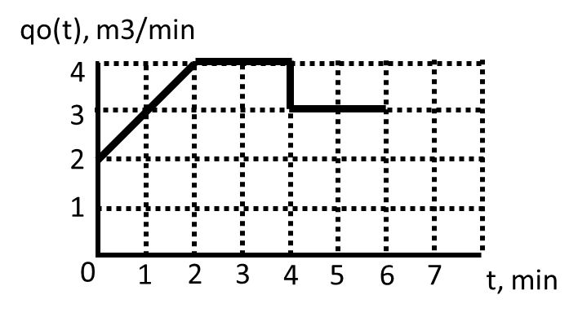
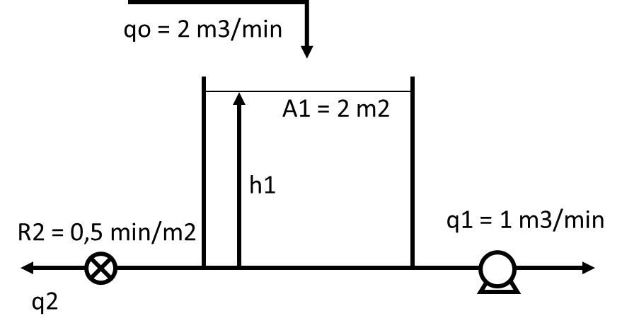
Στη δεξαμενή επιβάλλεται η μεταβολή του σχήματος. Να υπολογιστεί η στάθμη στο 2^{ο}, 3^{ο}, 4^{ο} και 6^{ο} λεπτό.

Ισοζύγιο μάζας: @SS 2 – 1 – hs/0,5 = 0 1 = hs/0,5 hs = 0,5
q(t) – q1 – h(t)/R2 = Adh(t)/dt Q(t) – H(t)/0,5 = 2dH(t)/dt Q(s) – 2H(s) = 2sH(s)
1 –2H/Q = 2sH/Q 1 = H/Q(2s + 2) H/Q = 1/(2s + 2) H/Q = 0,5/(s+1) (1)

q(t) = qs + t*u(t) – (t-2)*u(t-2) – u(t-4) q(t) - qs = t*u(t) – (t-2)*u(t-2) – u(t-4) Q(t) = t*u(t) – (t-2)*u(t-2) – 1u(t-4) Q(s) = 1/s2 – exp(-2s)/s2 – exp(-4s)

(1) H = 0,5/s2(s+1) – 0,5exp(-2s)/s2(s+1) – 0,5exp(-4s)/(s+1) (2)

HEAVYSIDE: 0,5/s2(s + 1) = A/s2 + B/s + C/(s + 1) A = 0,5 C = 0,5
0,5/s2(s + 1) = 0,5/s2 + B/s + 0,5/(s + 1) 0,5(s+1) + Bs(s+1) + 0,5s2 = 0,5
0,5s + 0,5 + Bs2 + Bs + 0,5s2 = 0,5 B = -0,5

(2) H = 0,5/s2 – 0,5/s + 0,5/(s+1) – 0,5exp(-2s)/s2 + 0,5exp(-2s)/s – 0,5exp(-2s)/(s+1) – 0,5exp(-4s)/(s+1)
H(t) = 0,5t-0,5+0,5exp(-t)-0,5(t-2)u(t-2)+0,5u(t-2)-0,5exp(-t+2)u(t-2)-0,5exp(-t+4)u(t-4)

H(2) = 0,5*2-0,5+0,5*exp(-2)-0,5*(2-2)+0,5-0,5*exp(-2+2) = 0,568 h(2) = 0,5 + 0,57 =1,57 m
H(3) = 0,5*3-0,5+0,5*exp(-3)-0,5*(3-2)+0,5-0,5*exp(-3+2) = 0,841 h(3) = 0,5 + 0,84 =1,34 m
H(4) = 0,5*4-0,5+0,5*exp(-4)-0,5*(4-2)+0,5-0,5*exp(-4+2)-0,5*exp(-4+4) = 0,441 m h(4) = 0,5 + 0,44 =0,94 m
H(6) = 0,5*6-0,5+0,5*exp(-6)-0,5*(6-2)+0,5-0,5*exp(-6+2)-0,5*exp(-6+4) = 0,924 m h(6) = 0,5 + 0,92 =1,42 m

