1^{η} Πρόοδος Δυναμική και Έλεγχος Διεργασιών 11 Σεπτεμβρίου 2018
ΘΕΜΑ1 (10μονάδες)
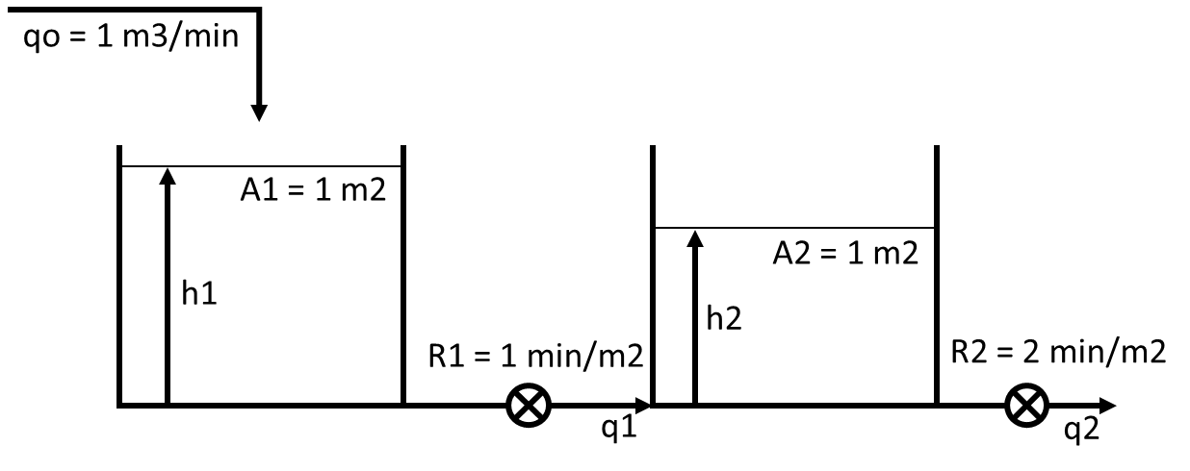
Σε χρόνο 0 προστίθεται στιγμιαία 1 m3. Να υπολογιστεί και να παρασταθεί γραφικά (σε χρόνο 0, 1, 2, 3, 4, 5 min) η απόκριση της στάθμης στην 1^{η} και τη 2^{η} δεξαμενή.

@SS 1 – (h1s – h2s)/1 = 0 (h1s – h2s) = 1 h1s = 3
(h1s – h2s)/1 – h2s/2 = 0 h2s = 2

Ισοζύγιο μάζας στην 1^{η} δεξαμενή
qo(t) – (h1(t) – h2(t))/R1 = A1*dh1(t)/dt Qo(t) – H1(t)/1 + H2(t)/1 = 1*dH1(t)/dt
Qo(t) – H1(t) + H2(t) = dH1(t)/dt Qo(s) – H1(s) + H2(s) = sH1(s) (1)

Ισοζύγιο μάζας στην 2^{η} δεξαμενή
(h1(t) – h2(t))/R1 – h2(t)/R2 = A2*dh2(t)/dt h1(t)/1 – h2(t)/1 – h2(t)/2 = 1*dh2(t)/dt
h1(t) – 1,5*h2(t) = dh2(t)/dt H1(t) – 1,5*H2(t) = dH2(t)/dt H1(s) – 1,5*H2(s) = sH2(s)
H1(s) = (s + 1,5)*H2(s) H2(s) = H1(s)/(s + 1,5)

(1) Qo(s) – H1(s) + H1(s)/(s + 1,5) = sH1(s) Qo/H1 – 1 + 1/(s + 1,5) = s Qo/H1 = s – 1/(s + 1,5) + 1
Qo/H1 = (s2 + 2,5s + 0,5)/(s + 1,5) H1/Qo = (s + 1,5)/(s2 + 2,5s + 0,5)
H1/Qo = s/(s2 + 2,5s + 0,5) + 1,5/(s2 + 2,5s + 0,5)

(1) Qo(s) – (s + 1,5)H2(s) + H2(s) = s(s + 1,5)H2(s) Qo/H2 = (s + 1,5) – 1 + s(s + 1,5)
Qo/H2 = s2 + 2,5s +0,5 = H2/Qo = 1/(s2 + 2,5s + 0,5)

Λύση τριωνύμου: Δ = 2,5^2-4*1*0,5 = 4,25 x1 = -0,22 x2 = -2,28

Κρουστική διαταραχή της παροχής: δ(t) = 1 Qo(s) = 1

HEAVYSIDE
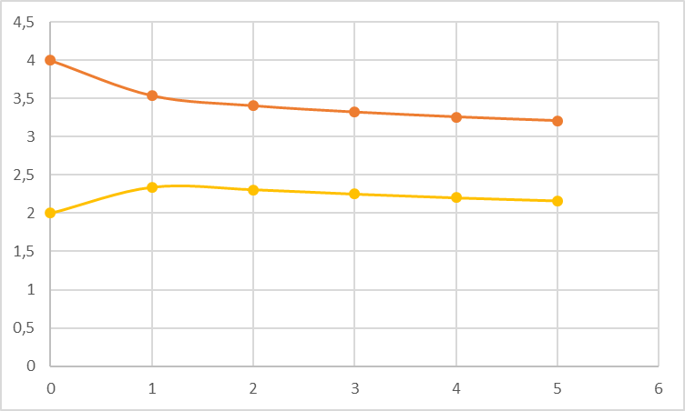
s/(s + 0,22)(s + 2,28) = A/(s + 0,22) + B/(s + 2,28)
A = -0,22/(-0,22+2,28) = -0,106
B = -2,28/(0,22-2,28) = 1,106

1,5/(s + 0,22)(s + 2,28) = C/(s + 0,22) + D/(s + 2,28)
C = 1,5/(-0,22+2,28) = 0,728
D = 1,5/(0,22-2,28) = -0,728

1/(s + 0,22)(s + 2,28) = E/(s + 0,22) + F/(s + 2,28)
E = 1/(-0,22+2,28) = 0,485
F = 1/(0,22-2,28) = -0,485

H1 = -0,106/(s+0,22) + 1,106/(s+2,28) + 0,728/(s + 0,22) – 0,728/(s + 2,28) = 0,621/(s+0,22) + 0,379/(s+2,28)
H1 =0,621*exp(-0,22*t)+0,379*exp(-2,28*t)

H2 = 0,485/(s+0,22) – 0,485/(s+2,28) H2 = 0,485*exp(-0,22*t)-0,485*exp(-2,28*t)

t | H1 | h1 | H2 | h2 | t | H1 | h1 | H2 | h2
0 | 1 | 4 | 0 | 2 | 3 | 0,321 | 3,321 | 0,250 | 2,250
1 | 0,537 | 3,537 | 0,340 | 2,340 | 4 | 0,258 | 3,258 | 0,201 | 2,201
2 | 0,404 | 3,404 | 0,307 | 2,307 | 5 | 0,207 | 3,207 | 0,161 | 2,161

ΘΕΜΑ 2 (10 μονάδες)
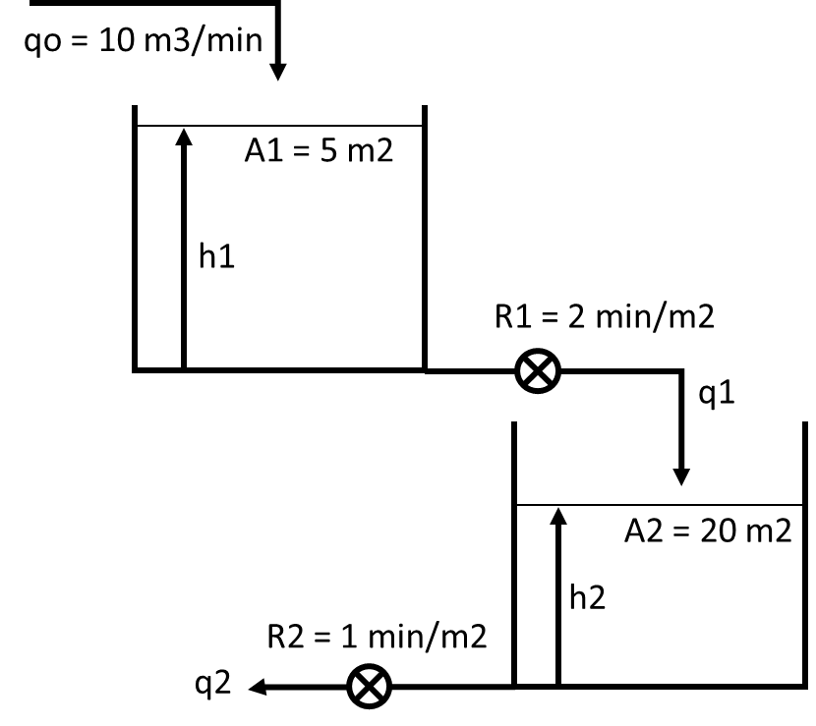

Στο σύστημα δεξαμενών η παροχή αυξάνεται με ρυθμό 1 m3/min. Να υπολογιστεί η στάθμη των δύο δεξαμενών σε χρόνο 5 και 10 λεπτά.

Γραμμική μεταβολή της qo: qo(t) = 10*u(t) + t*u(t) qo(t) – qos = t*u(t)
Qo(t) = t*u(t) Qo(s) = 1/s2

Ισοζύγιο μάζας στην 1^{η} δεξαμενή
@SS 10 – h1s/2 = 0 h1s = 20 m

qo(t) – h1(t)/R1 = A1*dh1(t)/dt Qo(t) – H1(t)/2 = 5*dH1(t)/dt
2*Qo(t) – H1(t) = 10*dH1(t)/dt 2Qo(s) – H1(s) = 10sH1(s)
2 – Η1/Qo = 10sH1/Qo H1/Qo*(10s + 1) = 2 H1/Qo = 2/(10s + 1) H1/Qo = 1/(5s + 0,5) (1) H1 = 1/s2(5s + 0,5) (2)

HEAVYSIDE 1/s2(5s + 0,5) = A/s2 + B/s + Γ/(5s + 0,5) Γ = 100 A = 2
1/s2(5s + 0,5) = 2/s2 + B/s + 100/(5s + 0,5) = (2(5s + 0,5) + Bs(5s + 0,5) + 100s2)/s2(5s + 0,5)
10s + 1 + 5Bs2 + 0,5Bs + 100s2 = 1 100 + 5B = 0 B = -20
10 + 0,5B = 0 B = -20

(2) H1 = 2/s2 – 20/s + 100/(5s + 0,5) = 2/s2 – 20/s + 20/(s + 0,1) H1(t) = 2t-20+20exp(-0,1t)

H1(5) = 2*5-20+20*exp(-0,1*5) = 2,13 m h1(5) = 20+2,13 = 22,13 m
H1(10) = 2*10-20+20*exp(-0,1*10) = 7,36 m h1(10) = 20+7,36 = 27,36 m

q1(t) = h1(t)/R1 Q1(t) = H1(t)/2 Q1(s) = H1(s)/2 H1 = 2Q1

(1) 2Q1/Qo = 1/(5s + 0,5) Q1/Qo = 0,5/(5s + 0,5) Q1/Qo = 1/(10s + 1)

Ισοζύγιο μάζας στην 2^{η} δεξαμενή q1(t) – h2(t)/R2 = A2*dh2(t)/dt Q1(t) – H2(t)/1 = 20*dH2(t)/dt
@SS 10 – h2s/1 = 0 h2s = 10 Q1(s) – H2(s) = 20sH2(s) 1 – Η2/Q1 = 20sH2/Q1
H2/Q1*(20s + 1) = 1 H2/Q1 = 1/(20s + 1) (3)

H2/Qo = (H2/Q1)*(Q1/Qo) = (1/(20s + 1))*(1/(10s + 1)) = 1/(20s + 1)(10s + 1)

H2 = 1/s2(20s + 1)(10s + 1) (4)

HEAVYSIDE 2/s2(20s + 1)(5s + 0,5) = A/s2 + B/s + C/(20s + 1) + D/(5s + 0,5) A = 4 C = 3200 D = -200
2/s2(20s + 1)(5s + 0,5) = 4/s2 + B/s + 3200/(20s+1) – 200/(5s+0,5) =
= 4(20s+1)(5s+0,5) + Bs(20s+1)(5s+0,5) + 3200s2(5s+0,5) – 200s2(20s+1)
400s2 + 60s + 2 + 100Bs3 + 15Bs2 + 0,5Bs + 16000s3 + 1600s2 – 4000s3 – 200s2 = 2
16000 - 4000 + 100B = 0 B = -120
400 + 15B + 1600 – 200 = 0 B = -120
60+0,5B = 0 B = -120

(4) H2 = 4/s2 – 120/s + 3200/(20s+1) – 200/(5s+0,5) = 4/s2 – 120/s + 160/(s+0,05) – 40/(s+0,1)
H2(t) = 4t-120+160exp(-0,05t)-40exp(-0,1t)

H2(5) = 4*5-120+160*exp(-0,05*5)-40*exp(-0,1*5) = 0,35 m h2(5) = 10+0,35 = 10,35 m
H2(10) = 4*10-120+160*exp(-0,05*10)-40*exp(-0,1*10) = 2,33 m h2(10) = 10+2,33 = 12,33 m

ΘΕΜΑ 3 (10 μονάδες)
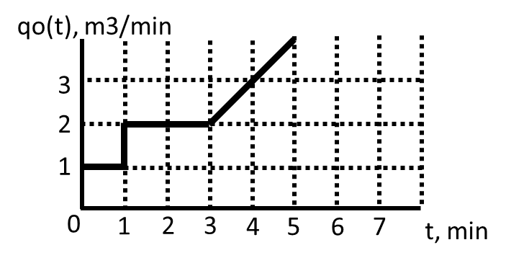
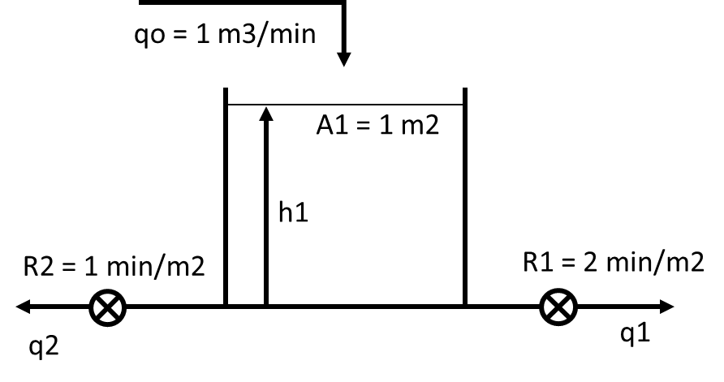
Στη δεξαμενή επιβάλλεται η μεταβολή του σχήματος. Να υπολογιστεί η στάθμη στο 2^{ο}, 3^{ο}, 4^{ο} και 5^{ο} λεπτό.

Ισοζύγιο μάζας: @SS 1 – hs – hs/2 = 0 1 = 3hs/2 hs = 2/3
q(t) – h(t)/R1 – h(t)/R2 = Adh(t)/dt Q(t) – H(t)/2 – H(t) = dH(t)/dt Q(s) – 3/2H(s) = sH(s)
1 – 1,5H/Q = sH/Q 1 = H/Q(s + 1,5) H/Q = 1/(s + 1,5) (1)

Q(t) = 1*u(t) + t*u(t-2) Q(s) = 1/s + exp(-2s)/s2

(1) H = 1/s(s + 1,5) + exp(-2s)/s2(s + 1,5) (2)

HEAVYSIDE: 1/s(s + 1,5) = A/s + B/(s + 1,5) = (2/3)/s – (2/3)/(s + 1,5)
1/s2(s + 1,5) = C/s2 + D/s + E/(s + 1,5) C = 2/3 E = 1/(-3/2)^2 = 1/(9/4) = 4/9
1 = (2/3)*(s + 3/2) + D*s*(s + 3/2) + (4/9)*s2 = (2/3)s + 1 + D*s2 + (3D/2)s + (4/9)*s2
D = -4/9 2/3 = - 3D/2 D = -4/9

(2) H = (2/3)/s – (2/3)/(s + 1,5) + exp(-2s)[(2/3)/s2 – (4/9)/s + (4/9)/(s + 1,5)]
H(t) = 2/3 – (2/3)exp(-1,5t) + [(2/3)(t – 2) – (4/9) + (4/9)exp(-1,5(t-2))]u(t – 2)

H(2) = 2/3-(2/3)*exp(-1,5*1) = 0,52 h(2) = 0,67 + 0,52 =1,19 m
H(3) = 2/3-(2/3)*exp(-1,5*2) = 0,63 h(3) = 0,67 + 0,63 =1,30 m
H(4) = 2/3-(2/3)*exp(-1,5*3) + (2/3)*(3-2)-(4/9)+(4/9)*exp(-1,5*(3-2)) = 0,98 m h(4) = 0,67 + 0,98 =1,65 m
H(5) = 2/3-(2/3)*exp(-1,5*4) + (2/3)*(4-2)-(4/9)+(4/9)*exp(-1,5*(4-2)) = 1,58 m h(5) = 0,67 + 1,58 =2,24 m

