TRANSCRIPTION WORKSHOP
Laurentianus Plut. 58.24 — Scribe D
Raffaella Cantore / Chiara Telesca
Scribe D begins his main contribution at folio 63 recto and copies, among other sections, parchment quire θ (folios 71–78), which contains most of the Metabaseis.
Although D’s ductus varies considerably throughout the manuscript — in speed and care of execution, letter size and formation, slant, writing angle, and the number and length of written lines — a number of recurring letterforms and ligatures make the hand recognisable.
- Nu — a distinctive “archer-shaped” form: the first vertical stroke is straight, while the second curves like a bow.
- Epsilon–pi ligature — the loop of epsilon rises above the horizontal stroke of pi and may lean markedly to the left, forming an angle with the initial vertical stroke of pi.
- Gamma — formed by two strokes converging towards the bottom; the following letter is attached to the top of the second stroke. The gamma–iota ligature is particularly characteristic.
- Omega — a closed form, sometimes flattened on the baseline, with a characteristic “sandwich-shaped” appearance.
- Beta–omicron ligature — a recurring diagnostic form attested in different sections written by D.
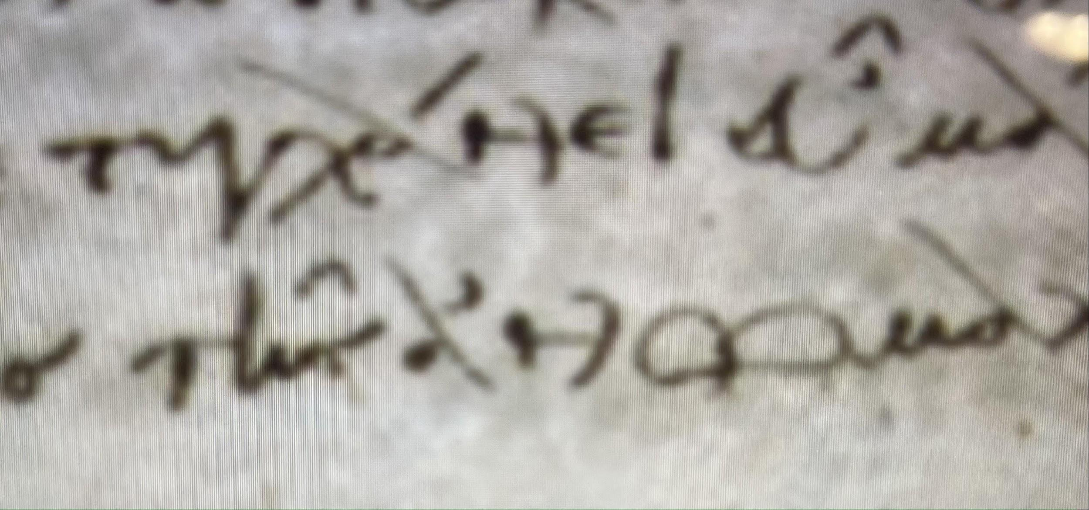  Nu  “Archer” shape: the first vertical stroke is straight, the second curves like a bow. | 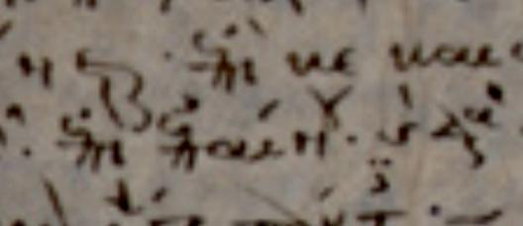  Epsilon–pi ligature  The loop of epsilon rises above the head-stroke of pi, leaning left and meeting its initial stroke.
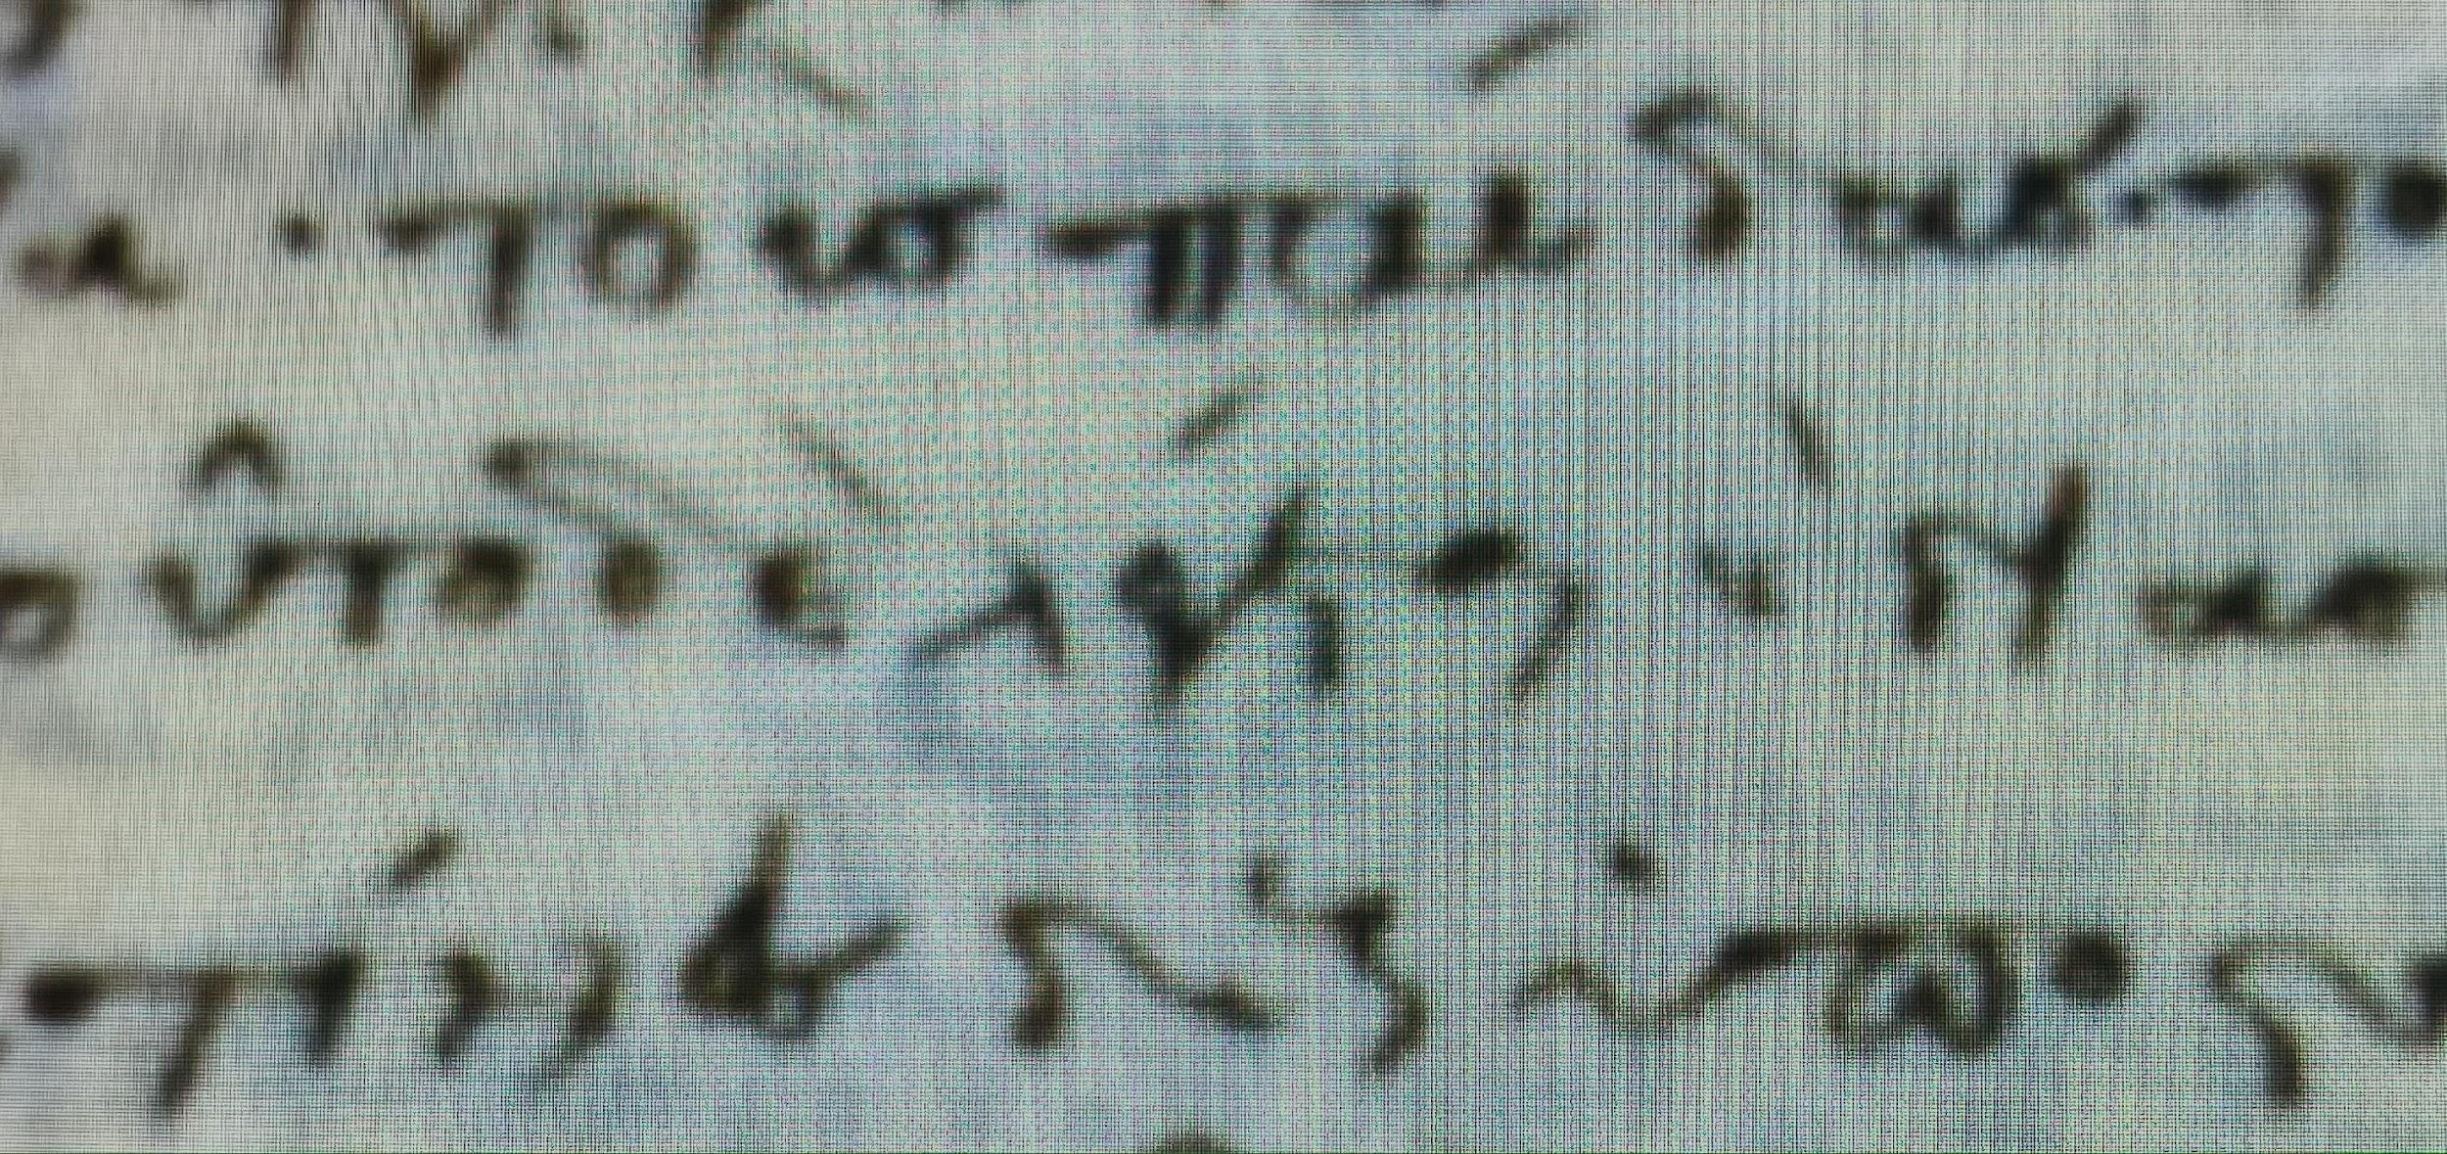  Gamma and its ligature  Two strokes converging at the base; the next letter attaches to the top of the second stroke. | 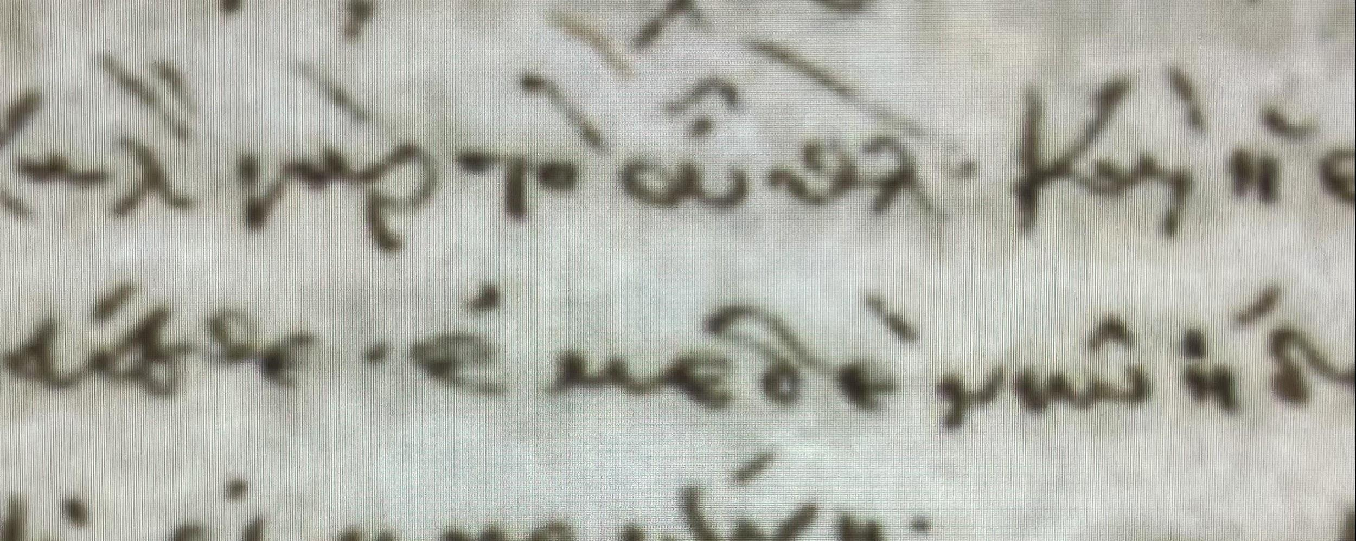  Delta and its ligature  Minuscule form only, with a very small loop — included here for comparison.
VARIATION WITHIN THE HAND
Individual folios can look strikingly different in module, spacing, number of lines, margins, and general degree of formality while retaining the same diagnostic letterforms and ligatures. For example, folio 67 recto has large letters, 22 lines, and a wide right margin; folio 92 recto has smaller letters, 26 lines, and a narrower right margin; folio 120 recto has 24 lines and no margin. The recurring forms of nu and the epsilon–pi ligature support their attribution to the same scribe.
SCRIBE D WITHIN THE MANUSCRIPT
D is also responsible for titles, enlarged or ekthesis letters, and numerous marginal glosses in sections copied by the professional calligrapher C. Some of these marginal additions supply omitted passages from Hermogenes’ Περὶ ἰδεῶν or excerpts from its commentary. These interventions show that D’s role extended beyond the straightforward copying of continuous text.
3. EXERCISE
Working from the manuscript photograph provided separately, transcribe fol. 71r line by line into the grid below. Mark ligatures you recognise above, note abbreviations, and flag any reading you are unsure of.
L. | Transcription
1
2
3
4
5
6
7
8
9
10
11
12
13
14
15
16

