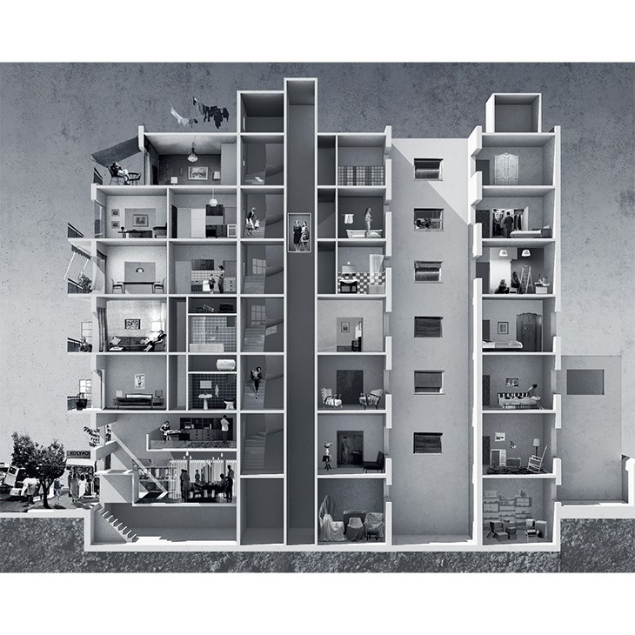
IMPRINTS OF AN URBAN MYTH: REPRESENTATIONS OF THE ATHENIAN POLYKATOIKIA / DISSERTATION AT NTUA, 2015 / A. AXAOPOULOU, E. PERTIGKIOZOGLOU
Editor: Anthi Rozi
Imprints of an urban myth: representations of the Athenian Polykatoikia | Dissertation | NTUA 2015
Students: Axaopoulou Anna, Pertigkiozoglou Eliza
Supervisors: Tournikiotis Panayotis, Tsiampaos Kostas

‘Polykatoikia’- the Athenian apartment building- constitutes the modular unit, which seems to have produced, through its repetition, Post-war Athens. A multifold of factors linked to the way of production, the legal framework, the ‘promoted’ lifestyle, defined the main principles of polykatoikia’s generic architecture. In order to better understand the banal and what represents nowadays the majority of the building stock of the Athenian urban center, we go back to the first post-war decades, a period that precedes and prepares for the extensive ‘cloning’ of apartment buildings the coming years.

At that time, polykatoikia emerged not only as a building type but also as a status symbol. ‘Architektoniki’, an expertized postwar architectural magazine aiming also to a broader public, was chosen as the medium through which we could revisit and reconstruct the forwarded perception of polykatoikia. Apart from being a documentation for the period, the magazine has contributed in constructing the imaginary around the polykatoikia – that of a multivalent ideal. The various publications act as different narratives highlighting our main issue of concern: they codify and reveal clues about the urban Model, its Rules and Norms, along with consulting the occupants with the Home Guide and promoting commercial Messages about the ‘ideal’ home.

The dissertation seeks to describe and recompose the urban myth via the representations of the magazine. Imprints of polykatoikia’s myth indicate, up to a great extent, the practice followed the next decades.

#01 Model
Before its extensive spread, an overview of respects included in the magazine seem to publicize Polykatoikia both as a model of urban development and a model of urban living, emerging from the urgency of development.

#02 Rules
A simplified version of the new legislation -1955’s General Building Regulation- published in the magazine systematizes its main features while it translates the legal framework into the familiar image of a ‘typical’ Polykatoikia’s section.

#03 Norms
Promulgation of prestigious examples of built Polykatoikias -usually belonging to prominent Athenians and designed by recognizable architects- informally validates and transmits social and organizational norms that could be altered or adapted when applied in cases with economic restrictions.

#04 Home Guide
Articles under the topic of interior arrangement and decoration provide readers with advice concerning domestic space. Apartment unit comes forward, given equal importance as the Model. A pursue of update of the residence typology is acknowledged.

#05 Messages
Commercials illustrate the ideal home, while apartment ownership emerges as the ultimate consumer dream. Messages about patterns of inhabiting and acting within domestic space are forwarded by the eye-catching images of advertisements.
The displayed images are collages of magazine’s material, which act complementary to the main body of the text as visual reconstructions of the imprint forwarded by the medium.

Find out more here.
