**EQUIPMENT**

|  |
| --- |
| catheter drain gauze swabs tongue depressor bandage roll hook kidney dish plaster pipette vaginal speculum  adhesive tape sling curette syringe tourniquet sterile gloves crutch scissors medicine pot bandage kidney dish stethoscope splint  non-contact thermometer forceps intravenous cannula scalpel |

****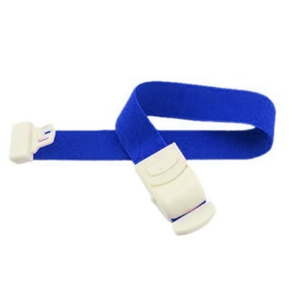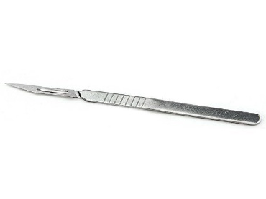

1. **2. 3.**

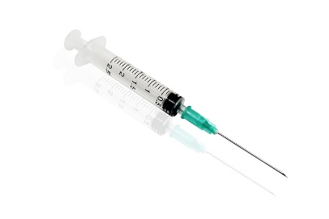

**4. 5. 6.**

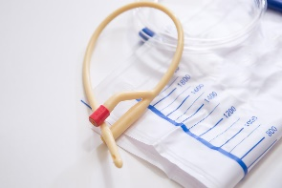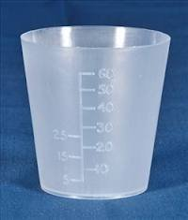

**7. 8. 9.**

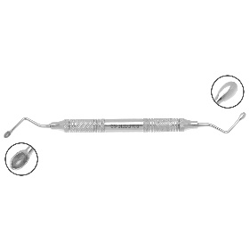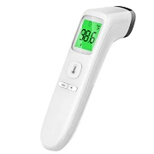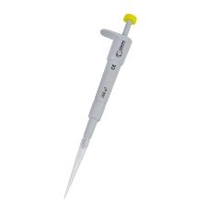

**10. 11. 12.**

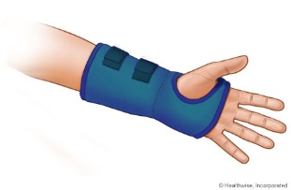

**13. 14. 15.**

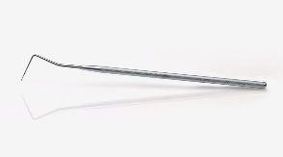

**16. 17. 18.**

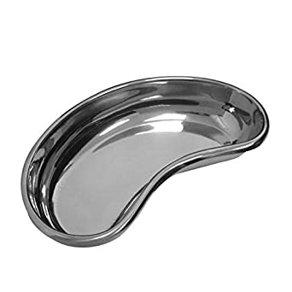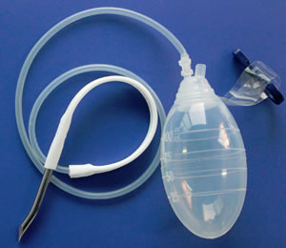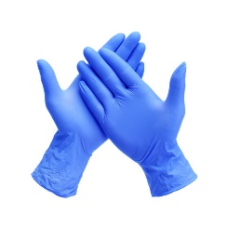

**19. 20. 21.**

[](http://www.google.gr/imgres?start=189&hl=el&rls=com.microsoft:el:IE-SearchBox&rlz=1I7WZPA_enGR327&biw=1016&bih=584&tbm=isch&tbnid=BA3piBwiHC_siM:&imgrefurl=http://www.silverlon.com/Alginate_Dressings_Guidelines.html&docid=RfZJUpIDcXru3M&imgurl=http://silverlon.com/images/2010_pics/CA_Dressing_475_520_400.jpg&w=520&h=440&ei=pOVyT-zIGsPj4QT5v8CNDw&zoom=1)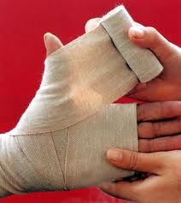

**22. 23. 24.**

[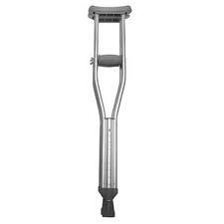](http://www.google.gr/imgres?hl=el&rls=com.microsoft:el:IE-SearchBox&rlz=1I7WZPA_enGR327&biw=1016&bih=584&tbm=isch&tbnid=dDvTbDhkMxmtKM:&imgrefurl=http://www.giantbomb.com/crutch/93-2655/&docid=4dody1oLn1s4QM&imgurl=http://media.giantbomb.com/uploads/1/13307/1099870-crutch_large.jpg&w=300&h=300&ei=jeZyT76FC7PP4QTD2LjJDw&zoom=1)[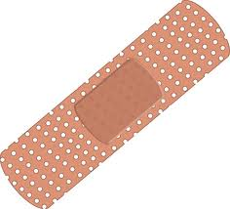](http://www.google.gr/imgres?hl=el&rls=com.microsoft:el:IE-SearchBox&rlz=1I7WZPA_enGR327&biw=1016&bih=584&tbm=isch&tbnid=9WNh1PMaQEIm7M:&imgrefurl=http://wpoprovider.com/%3Fattachment_id%3D146&docid=fWSnO-huKhAZIM&imgurl=http://wpoprovider.com/wp-content/uploads/2011/01/adhesive-bandage.jpg&w=500&h=453&ei=-ulyT7fkJcHb4QSaiaWCDw&zoom=1)

**25. 26.**