**INSTRUMENTS AND EQUIPMENT**

Match the following instruments and items of equipment with the images below.

|  |
| --- |
| adhesive tape, bandage, catheter, crutch, curette, dressing, drain, forceps, gauze swabs, intravenous cannula, kidney dish, medicine pot, pipette, plaster, probe, scalpel, scissors, sling, splint, sterile gloves, stethoscope, syringe, thermometer, tongue depressor, tourniquet, vaginal speculum |

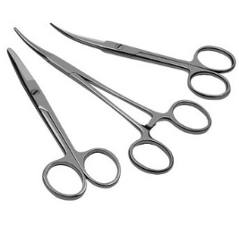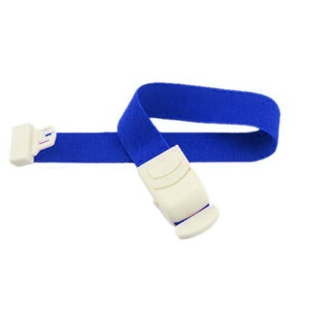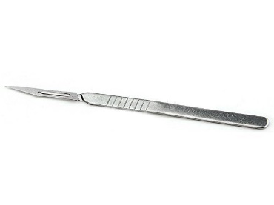

1. **2. 3.**

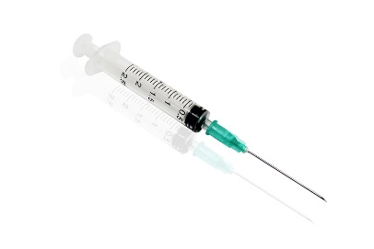

**4. 5. 6.**

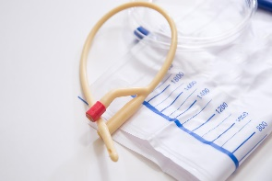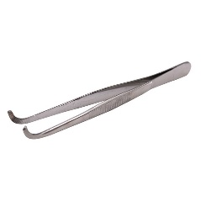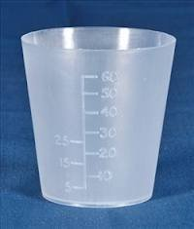

**7. 8. 9.**

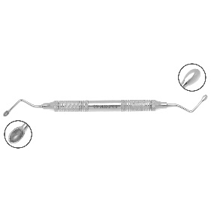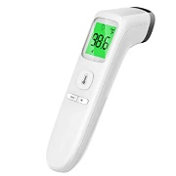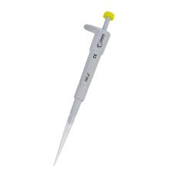

**10. 11. 12.**

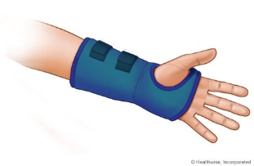

**13. 14. 15.**

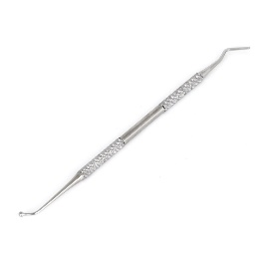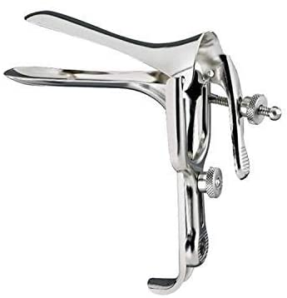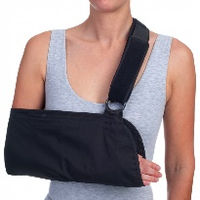

**16. 17. 18.**

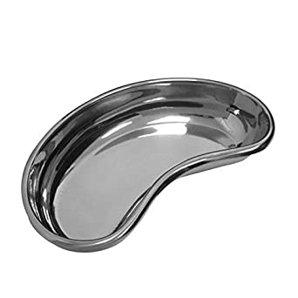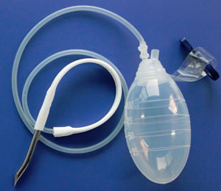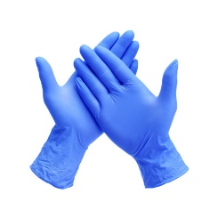

**19. 20. 21.**

[](http://www.google.gr/imgres?start=189&hl=el&rls=com.microsoft:el:IE-SearchBox&rlz=1I7WZPA_enGR327&biw=1016&bih=584&tbm=isch&tbnid=BA3piBwiHC_siM:&imgrefurl=http://www.silverlon.com/Alginate_Dressings_Guidelines.html&docid=RfZJUpIDcXru3M&imgurl=http://silverlon.com/images/2010_pics/CA_Dressing_475_520_400.jpg&w=520&h=440&ei=pOVyT-zIGsPj4QT5v8CNDw&zoom=1)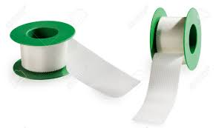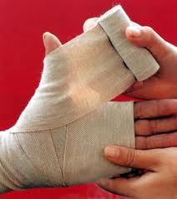

**22. 23. 24.**

[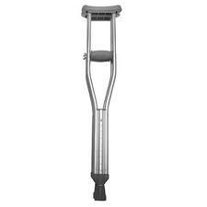](http://www.google.gr/imgres?hl=el&rls=com.microsoft:el:IE-SearchBox&rlz=1I7WZPA_enGR327&biw=1016&bih=584&tbm=isch&tbnid=dDvTbDhkMxmtKM:&imgrefurl=http://www.giantbomb.com/crutch/93-2655/&docid=4dody1oLn1s4QM&imgurl=http://media.giantbomb.com/uploads/1/13307/1099870-crutch_large.jpg&w=300&h=300&ei=jeZyT76FC7PP4QTD2LjJDw&zoom=1)[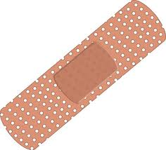](http://www.google.gr/imgres?hl=el&rls=com.microsoft:el:IE-SearchBox&rlz=1I7WZPA_enGR327&biw=1016&bih=584&tbm=isch&tbnid=9WNh1PMaQEIm7M:&imgrefurl=http://wpoprovider.com/%3Fattachment_id%3D146&docid=fWSnO-huKhAZIM&imgurl=http://wpoprovider.com/wp-content/uploads/2011/01/adhesive-bandage.jpg&w=500&h=453&ei=-ulyT7fkJcHb4QSaiaWCDw&zoom=1)

**25. 26.**