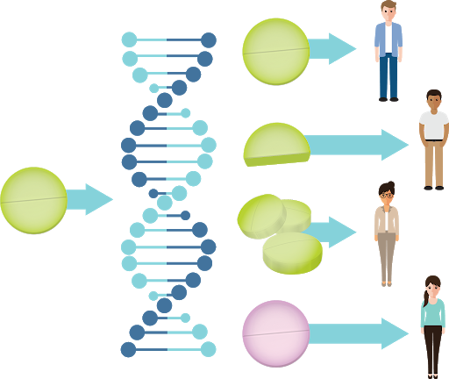
Pharmacogenomics

Pharmacogenomics is the study of the role of the genome in drug response. Its name (pharmaco- + genomics) reflects its combining of pharmacology and genomics. Pharmacogenomics analyses how the genetic makeup of an individual affects his/her response to drugs. It deals with the influence of acquired and inherited genetic variation on drug response in patients by correlating gene expression or single-nucleotide polymorphisms with pharmacokinetics (drug absorption, distribution, metabolism, and elimination) and pharmacodynamics (effects mediated through a drug's biological targets). The term pharmacogenomics is often used interchangeably with pharmacogenetics. Although both terms relate to drug response based on genetic influences, pharmacogenetics focuses on single drug-gene interactions, while pharmacogenomics encompasses a more genome-wide association approach, incorporating genomics and epigenetics (inheritance by mechanisms other than through the DNA sequence of genes) while dealing with the effects of multiple genes on drug response.
Pharmacogenomics aims to develop rational means to optimize drug therapy, with respect to the patients' genotype, to ensure maximum efficiency with minimal adverse effects. Through the utilization of pharmacogenomics, it is hoped that pharmaceutical drug treatments can deviate from what is dubbed as the "one-dose-fits-all" approach.
Pharmacogenomics also attempts to eliminate the trial-and-error method of prescribing, allowing physicians to take into consideration their patient's genes, the functionality of these genes, and how this may affect the efficacy of the patient's current or future treatments (and where applicable, provide an explanation for the failure of past treatments). Such approaches promise the advent of precision medicine and even personalized medicine, in which drugs and drug combinations are optimized for narrow subsets of patients or even for each individual's unique genetic makeup. Whether used to explain a patient's response or lack to a treatment, or act as a predictive tool, it hopes to achieve better treatment outcomes, greater efficacy, minimization of the occurrence of drug toxicities and adverse drug reactions (ADRs). For patients who have lack of therapeutic response to a treatment, alternative therapies can be prescribed that would best suit their requirements. In order to provide pharmacogenomic recommendations for a given drug, two possible types of input can be used: genotyping or exome or whole genome sequencing. Sequencing provides many more data points, including detection of mutations that prematurely terminate the synthesized protein.

Drug-metabolizing enzymes
There are several known genes which are largely responsible for variances in drug metabolism and response. Genes that are more widely accepted and utilized clinically are Cytochrome P450s, VKORC1, and TPMT.

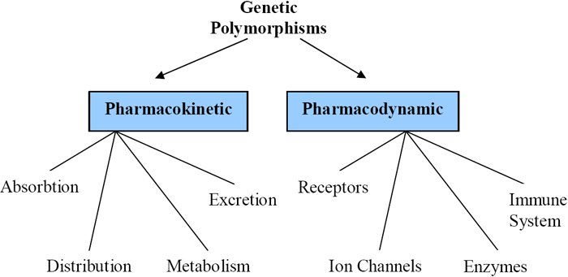
How does pharmacogenomics work?

Drugs interact with the body in numerous ways, depending both on how the drug is taken and where it acts in the body. After taking a drug, the body needs to break it down and get it to the intended area. DNA can affect multiple steps in this process to influence how the body responds to the drug. Some examples of these interactions include:
Drug Receptors: with many receptors there is a strong response to the drug - with few receptors there is a weak response to the drug - with no receptors there is no response to the drug and with different types of receptors the is also no response to the drug
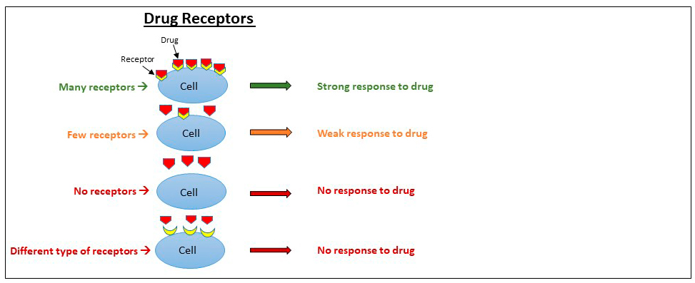
Example: Breast Cancer and T-DM1. Some breast cancers make too much HER2 ((human epidermal growth factor receptor 2), and this extra HER2 helps the cancer develop and spread. The drug T-DM1 can be used to treat this type of breast cancer and works by attaching to HER2 on cancerous cells and killing them. If you have breast cancer, your doctor may test a sample of your tumour to determine if T-DM1 is the right treatment for you. If your tumour has a high amount of HER2 (HER2 positive), your doctor may prescribe T-DM1. If your tumour does not have enough HER2 (HER2 negative), T-DM1 will not work for you.
Drug Uptake: with a normal uptake the drug works as expected - with a decreased uptake the drug can build up and cause problems
Example: Statins and Muscle Problems. Statins are a type of drug that act in the liver to help lower cholesterol. In order for statins to work correctly, they must first be taken into the liver. Statins are transported into the liver by a protein made by the SLCO1B1 (Solute Carrier Organic Anion Transporter Family Member 1B1) gene. Some people have a specific change in this gene that causes less of a statin called simvastatin to be taken into the liver. When taken at high doses, simvastatin can build up in the blood, causing muscle problems, including weakness and pain. Before prescribing simvastatin, your doctor may recommend genetic testing for the SLCO1B1 gene to check if simvastatin is the best statin for you or to determine what dose would work best.

Drug Breakdown: with a normal breakdown a normal dose of the drug is needed - with a fast breakdown more drug or a different drug is needed - with a slow breakdown less drug is needed
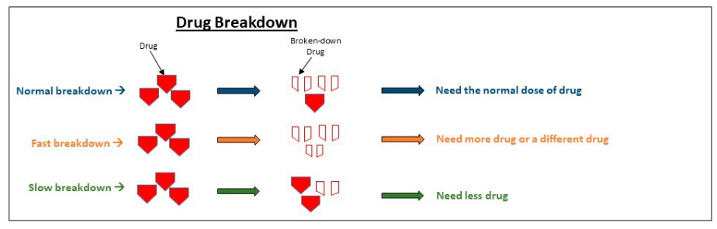
Example: Depression and Amitriptyline. The breakdown of the antidepressant drug amitriptyline is influenced by two genes called CYP2D6 (Cytochrome P450 Family 2 Subfamily D Member 6) and CYP2C19 (Cytochrome P450 Family 2 Subfamily C Member 19). If your doctor prescribes amitriptyline, he or she might recommend genetic testing for the CYP2D6 and CYP2C19 genes to help decide what dose of the drug you need. If you breakdown amitriptyline too fast, you will need a higher dose for it to work, or you may need to use a different drug. If you breakdown amitriptyline very slowly, you will need to take a smaller dose or will need to take a different drug to avoid a bad reaction.

Predictive prescribing
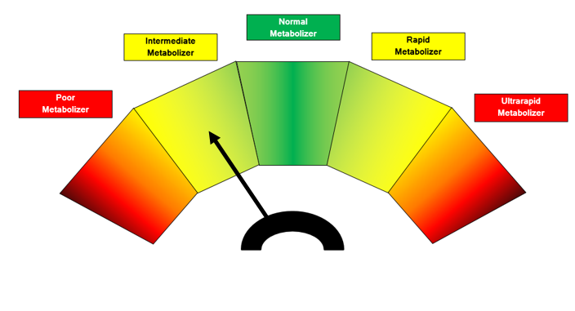
Patient genotypes are usually categorized into the following predicted phenotypes:
- Ultra-rapid metabolizer: patients with substantially increased metabolic activity
- Extensive metabolizer: normal metabolic activity
- Intermediate metabolizer: patients with reduced metabolic activity
- Poor metabolizer: patients with little to no functional metabolic activity.
The two extremes of this spectrum are the poor metabolizers and ultra-rapid metabolizers. Efficacy of a medication is not only based on the above metabolic statuses, but also the type of drug consumed. Drugs can be classified into two main groups: active drugs and prodrugs. Active drugs refer to drugs that are inactivated during metabolism, and prodrugs are inactive until they are metabolized.
CYP2D6 acts on a quarter of all prescription drugs. For example, it converts the painkiller codeine into its active form, morphine. There are more than 160 versions of the CYP2D6 gene. Many vary by only a single difference in their DNA sequence. Others have larger changes. Most of these variants don’t affect how people respond to the drug.
Typically, people have two copies of each gene. However, some people have hundreds or even thousands of copies of the CYP2D6 gene. Those with extra copies produce too much of the CYP2D6 enzyme and process the drug very fast. As a result, their bodies may convert codeine to morphine so quickly and completely that a standard dose can be an overdose. In contrast, some variants of CYP2D6 create an enzyme that doesn’t work. People with these variants process codeine slowly, if at all, leading to little, if any, pain relief. For them, doctors can prescribe a different drug.

How does pharmacogenetic testing work?
Pharmacogenetic tests look for genetic variants that are associated with variable response to specific medications. These variants occur in genes that code for drug-metabolizing enzymes, drug targets, or proteins involved in immune response. Pharmacogenetic tests have the ability to determine if a variant is heterozygous or homozygous, which can impact an individual's response or reaction to a drug.

When are the tests ordered?
A healthcare practitioner may test a patient's genes for certain variations that are known to be involved in variable response to a medication at any time during treatment. Testing may be ordered prior to starting specific drug therapies or if a person who has started taking a drug is experiencing side effects or having trouble establishing and/or maintaining a stable dose. Sometimes a person may not experience such issues until other medications that affect the metabolism or action of the drug in question are added or discontinued.
The results of the testing may be combined with the individual's clinical information, including age, weight, health and other drugs that they are taking, to help tailor therapy. Sometimes, the healthcare practitioner may use this information to adjust the medication dose or sometimes to choose a different drug. Pharmacogenetic testing is intended to give the healthcare practitioner additional information but may not replace the need for therapeutic drug monitoring.
Pharmacogenetic testing for a specific gene is only performed once since a person's genetic makeup does not change over time. Depending on the medication, a single gene may be ordered or multiple genes may be ordered. An example of a medication for which multiple genes are usually evaluated is warfarin, which can be affected by genetic variation in CYP2C9 and VKORC1.

Clinical implementation
Here are examples of research findings related to different medical conditions.

Case A – Antipsychotic adverse reaction
Patient A suffers from schizophrenia. His treatment included a combination of ziprasidone, olanzapine, trazodone and benztropine. The patient experienced dizziness and sedation, so doctors tapered off ziprasidone and olanzapine, and transitioned to quetiapine. Trazodone was discontinued. The patient then experienced excessive sweating, tachycardia and neck pain, gained considerable weight and had hallucinations. Five months later, quetiapine was tapered and discontinued, with ziprasidone re-introduction into their treatment due to the excessive weight gain. Although the patient lost the excessive weight they gained, they then developed muscle stiffness, cogwheeling, tremors and night sweats. When benztropine was added they experienced blurry vision. After an additional five months, the patient was switched from ziprasidone to aripiprazole. Over the course of 8 months, patient A gradually experienced more weight gain, sedation, developed difficulty with their gait, stiffness, cogwheeling and dyskinetic ocular movements. A pharmacogenomics test later proved the patient had a CYP2D6 *1/*41, which has a predicted phenotype of IM and CYP2C19 *1/*2 with a predicted phenotype of IM as well.

Case B – Pain Management
Patient B is a woman who gave birth by caesarean section. Her physician prescribed codeine for post-caesarean pain. She took the standard prescribed dose, however experienced nausea and dizziness while she was taking codeine. She also noticed that her breastfed infant was lethargic and feeding poorly. When the patient mentioned these symptoms to her physician, they recommended that she discontinue codeine use. Within a few days, both the patient and her infant's symptoms were no longer present. It is assumed that if the patient underwent a pharmacogenomic test, it would have revealed she may have had a duplication of the gene CYP2D6 placing her in the Ultra-rapid metabolizer (UM) category, explaining her ADRs to codeine use.

How is pharmacogenomics affecting drug design, development, and prescribing guidelines?
The Food and Drug Administration (FDA) now includes pharmacogenomic information on the labels of around 200 medications. This information can help doctors tailor drug prescriptions for individual patients by providing guidance on dose, possible side effects, or differences in effectiveness for people with certain gene variants.
Drug companies are also using pharmacogenomics to develop and market medicines for people with specific genetic profiles. By studying a drug only in people likely to benefit from it, drug companies might be able to speed up the drug’s development and maximize its therapeutic benefit.
In addition, if scientists can identify genes that cause serious side effects, doctors could prescribe those drugs only to people who do not have those genes. This would allow some individuals to receive potentially lifesaving medicines that otherwise might be banned because they pose a risk for other people.

Research findings related to different medical conditions

Heart Attacks and Strokes

For people who have had a heart attack or stroke, doctors often recommend daily doses of aspirin to lower the risk of recurrence. Aspirin works by reducing the activity of blood-clotting particles called platelets. Excess platelet activity can cause blood clots that lead to heart attacks and strokes.

About 60 million Americans take aspirin each day to prevent such problems. But in 10 to 30 percent of these people, it doesn't work. A team of researchers discovered a set of 60 genes whose activity can predict whether a person will benefit from aspirin therapy or not.

A different group of researchers focused on a gene called PEAR1, which codes for a protein on the surface of platelets. One spelling of the gene, with an A instead of a G at a particular spot, makes people more likely to have a heart attack, even while taking aspirin. For these people, doctors can prescribe other methods to prevent heart attacks and strokes.

Lung Cancer

Lung cancer is the number-one cause of cancer deaths in both men and women in the United States, and smoking leads to 80 to 90 percent of these cases. Smokers who can't quit might benefit from research on a gene called CYP2A13. This gene codes for a lung enzyme that converts a substance in tobacco into two cancer-causing molecules.

Scientists plan to explore whether blocking the activity of CYP2A13 could prevent the formation of these dangerous molecules and reduce the incidence of lung cancer among smokers.

Breast Cancer

For some women at high risk for breast cancer based on their age, family medical history or other factors, a long-term treatment with a class of drugs called selective oestrogen receptor modulators (SERMs) can cut the disease risk in half. Researchers recently discovered that women have the greatest chance of benefitting from the strategy if they have certain spellings in two locations—the ZNF423 gene and near the CTSO gene.

In the largest-scale analysis of its kind, such women were almost six times less likely to develop breast cancer during the 5-year course of treatment than were women with neither advantageous spelling. With this information, women and their doctors will be better able to balance the potential benefits and risks of the long-term preventive strategy.

Childhood Leukaemia

Drugs known as thiopurines are prescribed for a childhood cancer called acute lymphoblastic leukaemia (ALL) but getting the dose right is critical. To help them do so, doctors can examine the genetic spelling of a protein called TPMT in each patient. TPMT processes and inactivates thiopurines.

The most common genetic spelling of TPMT makes a protein that acts on thiopurines quickly. But about 10 percent of people have a variant spelling that produces a slower-acting protein. For these people, doctors can prescribe lower thiopurine doses—or different medications—to prevent the drug from building up to toxic levels before it's processed by the body.

Rheumatoid Arthritis

Rheumatoid arthritis causes swelling and pain in a person's joints, usually in the hands and feet. It happens when the body's immune system mistakenly attacks the joints using an arsenal of inflammation-producing molecules. Decades ago, researchers discovered that blocking a single molecule, TNF-alpha, could turn down this inflammatory response. Now, medicines that turn off TNF-alpha are used to treat rheumatoid arthritis and a number of related disorders.

Scientists found that the effectiveness of a TNF-alpha blocker called etanercept depends on the spelling of a gene called CD84. For two other TNF-alpha blockers, the spelling of CD84 doesn't matter. This discovery will help researchers understand differences in how the three drugs work in the body, possibly paving the way for personalized prescriptions based on an individual's version of CD84 or other genetic factors.

Polypharmacy
A potential role pharmacogenomics may play would be to reduce the occurrence of polypharmacy. It is theorized that with tailored drug treatments, patients will not have the need to take several medications that are intended to treat the same condition. In doing so, they could potentially minimize the occurrence of ADRs, have improved treatment outcomes, and can save costs by avoiding purchasing extraneous medications. An example of this can be found in psychiatry, where patients tend to be receiving more medications than even age-matched non-psychiatric patients. This has been associated with an increased risk of inappropriate prescribing.

What are the potential limitations of pharmacogenomics?
While an individual’s genetic makeup is important in determining the best treatment for many drugs, it does not explain how all drugs are broken down. There are still medications for which there are no drug-gene tests; the tests only involve some of the many genes in the body. Results of a test represent just one piece of information among many. Other information must be considered when choosing an appropriate medication therapy, such as:
- The person's current medications and how they may affect the breakdown of other medications.
- Any other diseases the person may have.
- The person's lifestyle including diet, exercise, tobacco, and alcohol consumption.
Pharmacogenomics cannot replace a healthcare professional in evaluating a patient and determining the best treatment option.
Exercises

Decide whether the following statements are true or false
If an individual has the same variant nucleotide in both copies of his or her genes, that person is said to have a heterozygous variant.
Pharmacogenetic testing is intended to give the healthcare practitioner additional information and may replace the need for therapeutic drug monitoring.
Pharmacogenetics focuses on single drug-gene interactions.
The risk of a drug-drug interaction decreases with the number of drugs used. When there are different types of receptors there is a strong response to the drug.
Pharmacogenomics can help in side effect reduction.
A larger dose is needed when the drug breakdown is slow.
DNA variants are associated with individual response to specific drugs.
Pharmacogenomic tests are available for all medications.

Complete with an appropriate term
adverse, binds, dosage, challenge, classes, concentrations, factors, follow-up, inactive, individualize, inherited, initiating, interactions, metabolized, monitoring, predominate, profile, rate, reactions, response, side effects, variable
Some of us respond differently than others to the same medications that we take, or we may experience different side effects from drugs. The way we respond can be due to the genes we have …………………... With respect to drugs, our unique genetic …………………... and our individual response may mean that a drug that is effective for one person may be less effective for another or that a drug that is safe for one person may be less safe for another person—even at the same …………………...
Most drugs are …………………... in the body by various enzymes. In some cases, an active drug is made …………………... through metabolism. In other cases, an inactive (or less active) drug is made more active through metabolism. The …………………... in drug therapy is to make sure that the active form of a drug stays around long enough to do its job. However, some people have …………………... enzyme action so that they may metabolize the drug too quickly or too slowly or not at all — meaning that the drug may not produce its intended effect or it may remain in a person's system too long and may lead to …………………....
Individual response to a drug may also be related to variability in the drug target, for example a protein that the drug …………………... to in order to produce its specific effect. Furthermore, individuals may experience hypersensitivity …………………... from certain medications due to variability in proteins involved in the immune …………………....
The decision about which drug to prescribe may also be influenced by other drugs the person is taking in order to avoid drug-drug ………………….... When …………………... drug therapy to treat a particular condition, healthcare practitioners typically prescribe one of several appropriate drugs. Dosages and timing of drugs are usually based upon the anticipated …………………... of metabolism and clearance from the body in the average person. They prescribe a "standard" dose based on …………………... such as weight, sex, and age.
The …………………... or effects of some drugs are monitored with blood tests and the drug dosages may be increased or decreased to maintain the drug level in an established therapeutic range. …………………... of drug concentration is called therapeutic drug ………………….... If changing the drug dose is not effective in treating or controlling the person's condition, or the person still has side effects, then the person may be given a different drug.
Pharmacogenetics offers healthcare providers the opportunity to …………………... drug therapy for people based on their genetic make-up. Testing people prior to initiating drug therapy to determine their likely response to different …………………... of drugs is a key emerging area of testing. Such genetic information could prove useful to both the healthcare practitioner and patient when choosing current and future drug therapies and drug doses. For certain medications, pharmacogenetics is already helping healthcare providers …………………... proper therapies and dosages to have a better chance of achieving the desired therapeutic effect while reducing the likelihood of …………………... effects.

